City of Seattle, Washington
Request for Information
for
Collaboration and/or Partnership between the City of Seattle and Private Sector Entities for Wireless Services and Potential Smart Cities Deployments,
Including in Low-Income Districts, and Parks

Schedule. The following is the estimated schedule of events. The City of Seattle (“City”) reserves the right to modify this schedule at its discretion. Notification of changes will be posted on the City’s website at http://consultants.seattle.gov/
RFI Release | 01/30/17 @ 2:00 PM PT
Optional Pre-Proposal Conference | 02/13/17 @ 9:00 AM PT  Skype Meeting  206-386-1200  844-386-1200  Conference ID: 8005673
Deadline for Proposer Questions | 02/15/17 @ 2:00 PM PT
RFI Responses Due to the City | 02/28/17 @ 2:00 PM PT

Procurement Contact

Seattle IT Contracting Advisor: Jeremy Doane – jeremy.doane@seattle.gov

Unless authorized by the IT Contracting Advisor, no other City official or employee may speak for the City regarding this solicitation until award is complete. Any Proposer contacting other City officials or employees does so at Proposer’s own risk. The City is not bound by such information.

Contents
I. Introduction 1
II. Goals for this Initiative 1
III. The City’s Vision for this Initiative: Digital Equity, Innovative City Services, and Improved Quality of Life 3
a. Digital Equity 3
b. Innovative City Services and Improved Quality of Life 5
IV. Geographic Priority Areas 6
a. Digital Equity Locations 8
b. City Parks 20
V. City Contributions and Assets 26
VI. RFI Response Requirements 27
VII. Confidentiality and Personal Presentations 29
VIII. RFI Response Process 30
a. Questions 30
b. Proposal Deadline 30
c. Summary of RFI Process Deadlines 30
Appendix A1: Non-Disclosure Agreement 31
Appendix A2: Non-Disclosure Request Form 31
Appendix B: City of Seattle Traffic Pole Locations and 32
Appendix C: Removed 33
Appendix D: City of Seattle Property Locations 34
Appendix E: King County Bus Shelter Locations 35
Appendix F: Fiber Availability in Priority Areas 36

Figures
Figure 1: Wireless Priority Areas 7
Figure 2: Yesler Terrace 8
Figure 3: High Point 9
Figure 4: South Park 10
Figure 5: Rainier Vista 11
Figure 6: Othello 12
Figure 7: Rainier Beach 13
Figure 8: Lake City 14
Figure 9: Roxbury Street Corridor 15
Figure 10: 23 Ave Corridor (Central District) 16
Figure 11: Judkins Park 17
Figure 12: Jimi Hendrix Park 18
Figure 13: Pratt Park 19
Figure 14: Magnuson Park 20
Figure 15: Camp Long 21
Figure 16: Discovery Park 22
Figure 17: Westlake Park 23
Figure 18: Occidental Square 24
Figure 19: Waterfront Park 25

Introduction
The City of Seattle, Washington (“the City”) issues this Request for Information (RFI) to gauge the interest of for-profit and non-profit entities in forming collaborations or partnerships with the City to enable the deployment of wireless services in Seattle. The City is seeking ideas from the private sector with regard to ways that public and private sectors can work together, with the City as facilitator, enabler, and potential partner to the private sector, in deploying wireless network infrastructure to support key goals.
In addition to both competitors and incumbents of the communications industry, the City seeks responses from a wide range of non-traditional entities that may be interested in this initiative, including such potential respondents as:
- Companies involved in the emerging Smart Cities ecosystem, including solutions providers and manufacturers
- Companies involved in the emerging drone and aerial vehicle ecosystems
- Non-profit organizations
- Local businesses, including those in the technology sector that have expertise to lend and a stake in the benefits that ubiquitous broadband offers, such as workforce preparation, or that see wireless service to lower income parts of the community as a mission worth supporting
- Manufacturers of relevant equipment, including of network equipment and of the physical housing and platforms for wireless services
- Nontraditional wireless providers (e.g., technology companies, technology integrators, software providers, and engineering companies)
- Public cooperatives
- Investors
The City will review responses to this RFI and may provide more detailed information on available City assets and ask one or more respondents to refine their responses. The City may also issue a more detailed Request for Proposal (RFP) relating to this project, cancel or delay plans for this initiative, or choose another direction that is deemed in the community’s best interest.
No contract will be awarded as a result of this RFI. Further, there is no guarantee an RFP will be developed as a result of this RFI. The City reserves the right to withdraw the RFI or any subsequent RFP, or decline to award a contract.
We ask that all respondents complete the attached non-disclosure agreement (Appendix A1) in the format specified in the RFI instructions.

Goals for this Initiative
Among the City’s goals are the following:
- The City seeks to increase connectivity for its underserved and underrepresented residents by prioritizing low cost or free access in disadvantaged and underserved areas of the City, including:

  - City Districts – The City seeks a partner to offer services in twelve disadvantaged Districts/Corridors, primarily for free or low-cost public use.

  - Parks – The City seeks a partner to offer services in six City parks, primarily for free public use.

- The City is open to creative solutions beyond the baseline requirements for the districts and parks if those solutions will maximize investment while providing reliable and high-quality services to meet the needs of the broader community.

- The City seeks to utilize its assets, capabilities, and other attributes to enable deployment of new and cost-effective wireless services. Among other assets, the City may be able to make use of conduit, fiber, and wireless siting locations.

- The City will consider, if appropriate, capital contributions toward one or more projects considered. With respect to cost, the City is interested in various financially sustainable business models that further the City’s goals and can easily be scaled. The City seeks partnerships with private entities that will ensure the sustainability of any services deployed under this initiative.

- The City seeks to maximize its processes and structures to best enable and facilitate new and cost-effective wireless services. In keeping with Mayor Ed Murray’s ongoing commitment to enable private deployment of broadband facilities, the City seeks to determine strategies by which to make itself as friendly as possible to private broadband investment.

- The City seeks to leverage its growing expertise and interest in a range of Smart Cities applications and functions, and to ensure that Smart Cities initiative in Seattle benefit all areas of the City equally, including the lower income areas that are of particular priority for this effort. While this RFI is not focused on Smart Cities, we recognize that there exists tremendous overlap among the areas of wireless, public access services, Smart Cities, and the Civic Internet of Things. We welcome creative responses to this RFI that offer private sector expertise and recommendations for how Smart Cities applications can support digital equity goals and vice versa.

- The City seeks input from potential collaborators or partners regarding the terms and conditions under which they would participate in such projects. The City seeks responses from potential partners with a variety of business models that share technological and operational responsibilities and financial risk between the partners and the City in innovative ways.

- The City encourages respondents to share their expertise, which may be used to shape the direction and form of the public-private collaboration the City seeks. The City further encourages respondents to work together on responses to this RFI if a collaborative approach would best meet the City’s goals.

- The City is also interested in learning more about what assets and contributions would facilitate the deployment of the provider’s solution. Respondents should discuss permitting, rights-of-way, property usage, conduit access, fiber connections, electricity requirements, and any other required or beneficial contributions.

- The City prefers options that require little to no investment by the City, but the City may be able to provide some capital to support the development of these networks.

The City’s Vision for this Initiative: Digital Equity, Innovative City Services, and Improved Quality of Life

Seattle is experiencing large increases in urban population, visitors, and the number of businesses that are developing in or relocating to the City. The City currently has 686,800 residents, and has grown by 17 percent over the last two decades. This growth is expected to continue through the foreseeable future. These increases create new challenges in handling street traffic, foot traffic, and data traffic, as well ensuring a safe and sustainable environment for the City’s residents and businesses. At the same time, the expectations of the City’s residents, visitors, and businesses are undergoing a massive shift toward greater demand for connectivity, immediacy, sustainability, and safety. Technological advances in fiber, wireless, sensors, big data analytics, and connected devices have created avenues for the City to meet those demands.

Digital Equity
Seattle Public Schools (SPS) reflect the tremendous diversity of the City. Serving more than 53,000 students across 98 schools, SPS is the largest district in the state. Notably, SPS has the largest English Language Learning (ELL) student population in Washington, with its students representing 97 countries and speaking over 127 different languages. The City recently implemented state of the art wireless technology in all of its classrooms; however, the proposed Wi-Fi network would allow this connectivity to extend beyond the classroom, so that the City’s low-income students can take their learning home.
Seattle is noted for its technology sector, housing some of the most advanced and connected industries in America. Notable employers include: Boeing, Microsoft, Amazon, and the University of Washington. Yet, it is also a city of contrasts. In 2011, 15 percent of City residents had incomes below the poverty threshold ($18,000), compared to a median household income of $61,000.
Many of these low-income residents lack connectivity. Although home Internet access in Seattle has increased from 57 percent to 85 percent in the past decade, barriers still prevent the City’s poorest residents from connecting. Indeed, a 2014 study on information technology access and adoption confirmed that:

- 15 percent of Seattle residents don’t have Internet access at home. The percent without access was higher for our immigrant/refugee families
- 20 percent of Seattle residents rely on public locations like libraries to use computers
- Residents earning under $20,000 per year were about 25 percent less likely to use the Internet than those earning more than $100,000 per year.

This inequity can be attributed, in part, to unaffordable Internet plans, lack of awareness about low-cost options, limited WiFi access in public spaces, and low-income housing developments that do not include adequate wiring for broadband.

To overcome these barriers, Seattle Mayor Edward Murray has launched a Digital Equity Initiative, where technology is used to equitably empower all residents and communities – especially those who are historically underserved or underrepresented. Consistent with this effort, the City seeks to ensure all that all of its residents and neighborhoods – regardless of income or resources – have the information technology capacity needed for civic and cultural participation, employment, lifelong learning, and access to essential services.
As part of its Digital Equity Initiative, earlier this year, the City’s IT Community Technology program released the Digital Equity Action Plan, which was developed in partnership with more than 100 community leaders, non-profit organizations, companies, and members of the public. The plan calls for the City to focus on three goals for increasing digital equity:
- Expand digital skills training opportunities for all residents;
- Ensure affordable, available, and sufficient devices and technical support; and
- Ensure sufficient options for affordable and available internet connectivity.
This RFI advances the third goal by seeking to identify a partner to improve high-speed Internet infrastructure, increase Internet availability to all individuals, and enhance connectivity in public spaces.
The City seeks to enhance connectivity for a growing population of underrepresented residents, small businesses, organizations and communities by:
- Improving high-speed internet infrastructure, including providing adequate access for high-speed internet service in multiple dwelling units (MDUs);
- Improving Internet availability to individuals, e.g., through the expansion of a Seattle Public Library personal hotspot lending program;
- And improving free connectivity in public spaces, including charging options for devices in community centers and libraries, building-wide Wi-Fi at Parks and Recreation community centers, and expanding access in disadvantaged and underserved areas of the city (e.g., transit tunnels, homeless encampments, and parks & rec centers).
The City has already advanced a number of broadband initiatives to lower the digital divide:
- Gigabit Service Availability and Competition. To attract new broadband investment, the City simplified the permitting process and was selected in 2014 as one of CenturyLink’s gigabit cities. Wave Broadband has also begun deploying fiber-to-the-premises (FTTP) gigabit internet service to Seattle homes. As a result of this interest, more than 160,000 Seattle homes have access to gigabit speed broadband.
- Public/private partnerships: Seattle made its spare fiber optic network capacity available to Internet service providers wanting to expand their service. In 2015, Cascade Networks became the first company to lease portions of the City’s dark fiber to provide Internet access in the International District.
- The Seattle Public Library’s Wi-Fi Hot Spot Program: The Seattle Public Library initiated a program to loan Wi-Fi hotspots (small devices that provide users with Wi-Fi connection and Internet service) to residents. In 2015, the Library provided 325 hotspots for use by library patrons and will increase that number to 725 in 2016.
- ConnectHome Partnership: In 2015, the City of Seattle and Seattle Housing Authority were selected to participate in the U.S. Department of Housing and Urban Development’s (HUD) ConnectHome initiative. Through this initiative, HUD seeks to accelerate broadband adoption by children and families living in HUD-assisted housing. The program components include broadband deployment, free or discounted Internet service for residents, and digital skills training
This RFP seeks to deepen the City’s commitment to digital equity by enhancing connectivity for underrepresented residents.

Innovative City Services and Improved Quality of Life
The City also seeks to offer innovative City services and enhance the quality of life for all of its residents by developing and enhancing new and existing infrastructure and devices. Recognizing that the City population will continue to grow, but that government staff per capita will not increase at a similar rate, the City has embraced technology to create new opportunities to reduce traffic congestion, fight crime, foster economic development, reduce greenhouse gas emissions, and make local governments more open, responsive, and efficient. The City has adopted or is pursuing a suite of progressive initiatives to advance these goals. For instance:
- Open Data: Since the launch of the City’s Open Data Program in 2010, more than 400 datasets have been made open. This data powers tools hosted on the City’s website such as Open Budget, Performance Seattle, the Police Department’s Neighborhood Crime Map and the Department of Transportation’s Capital Projects Explorer.
- Focus on Privacy: Data collection has become more pervasive, with potentially compromising information gathered every time a resident pays a utility bill, renews a pet license, or reaches out to emergency responders. To address this, the City launched a Privacy Initiative in 2014 to ensure that the City takes appropriate steps to facilitate the collection, use, and disposal of data in a manner that balances the needs of the City to conduct its business with individual privacy.
- Array of Things: Seattle will be one of nine North American and global cities to participate in the Array of Things project, an urban sensing project that will feature a network of interactive, modular sensor boxes installed around the City to collect real-time data on the city’s environment, infrastructure, and activity for research and public use. The Array of Things will enable the City to measure factors that impact livability such as climate, air quality and noise.
As part of this RFI, the City is seeking to learn how these and other Smart Cities initiatives can support, enhance, or complement the public’s demands for connectivity by providing public wireless service, with a particular (but not exclusive) focus on the needs of lower income residents of Seattle and those who lack adequate access to Internet connectivity.

Geographic Priority Areas
The City does not wish to limit the scope of responses to specific locations; it is open to respondents identifying areas where they wish to provide wireless networking solutions. However, the City has identified locations where wireless solutions would be most welcome. These priority areas include 12 districts deemed important to improving access to the Internet for lower income members of the community, and six parks where wireless access would support various services and enable general use by the public. Figure 1 illustrates the locations of these priority areas throughout the City; the sections below describe each area in more detail. The City would also welcome wireless solutions at institutions that serve the homeless population.
Figure 1: Wireless Priority Areas
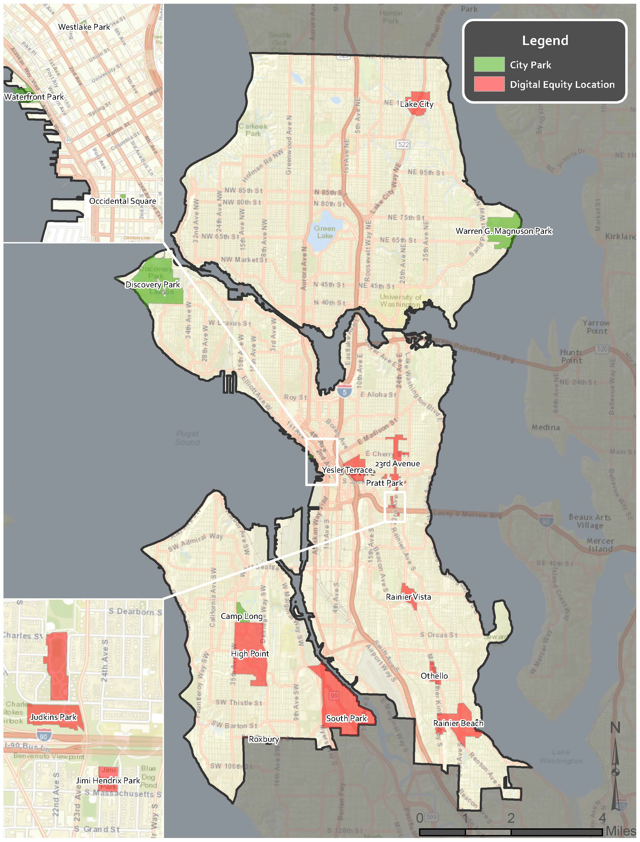

Digital Equity Locations
Yesler Terrace is a 30-acre site near downtown Seattle. Originally built in the 1940s as the City’s first publicly subsidized housing, the area has been undergoing revitalization since 2013. The fully revitalized area will feature 4.3 million square feet of housing with more than 5,000 units, 900,000 square feet of office space, and 88,000 square feet of retail space. The redevelopment will continue the City’s commitment to affordable housing: A minimum of 561 units will be set aside for very-low-income households earning less than 30 percent of the area median income (AMI), 290 units will be reserved for households earning less than 60 percent of the AMI, and 850 units will be reserved for households earning less than 80 percent of the AMI.
Figure 2: Yesler Terrace
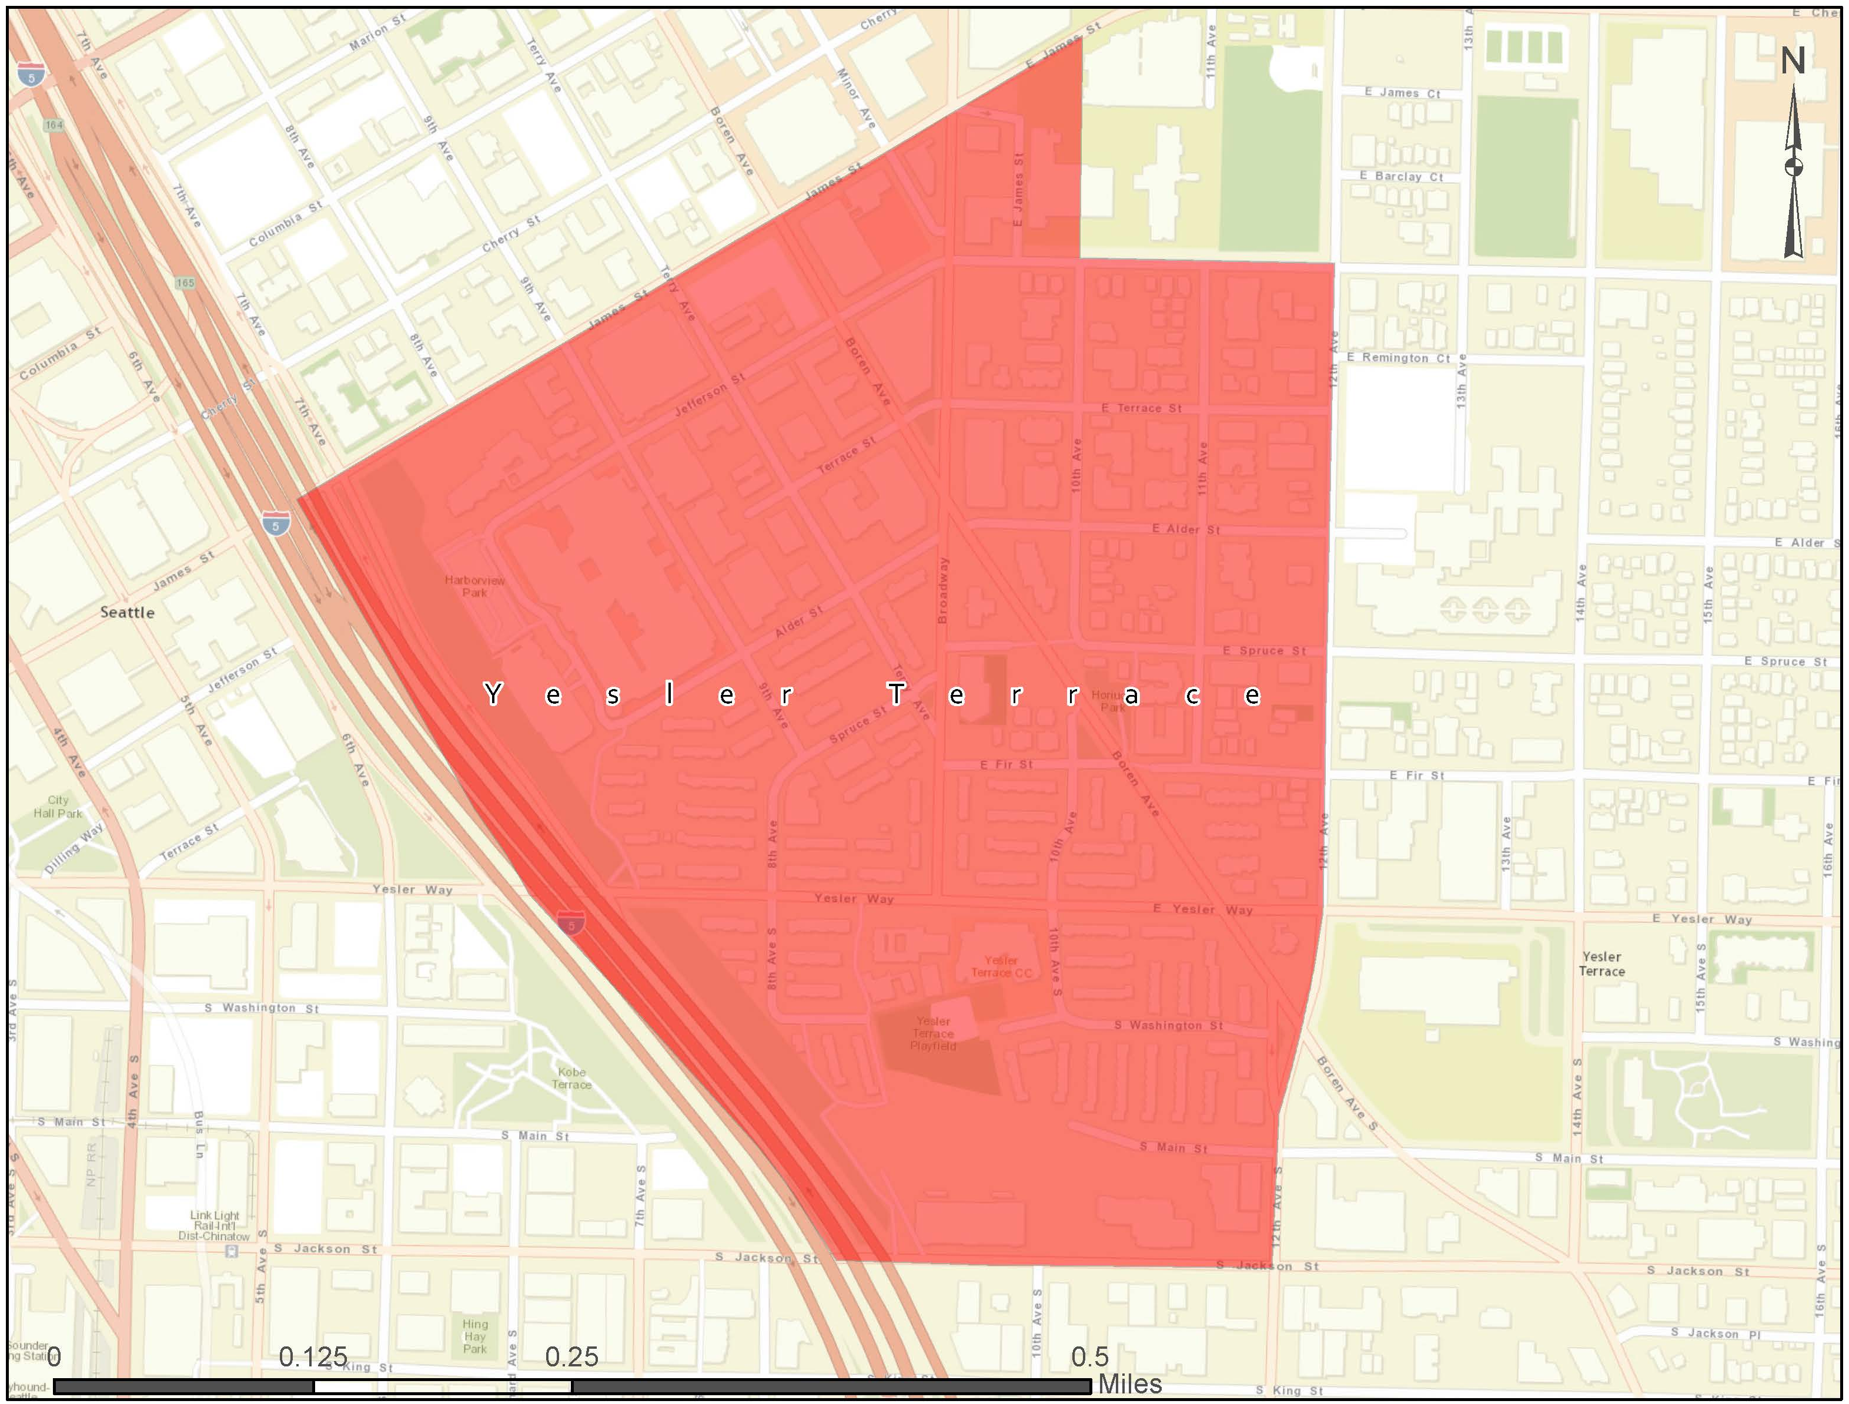

High Point is a .84-square-mile low-income neighborhood in Seattle. 2000 Census data revealed that more than 30 percent of residents in the community were living in poverty, compared to 11 percent citywide. In 2004, the district underwent redevelopment after the City received funding from the U.S. Department of Housing and Urban Development’s HOPE IV grant. The project’s goals included improving the district while maintaining housing for all income levels. The redeveloped district includes 350 units of public housing set aside for residents with incomes of 50 percent of the AMI or lower. It also has 250 affordable rental units and 56 affordable for-sale units reserved for residents with incomes of 80 percent of the AMI or lower.
Figure 3: High Point
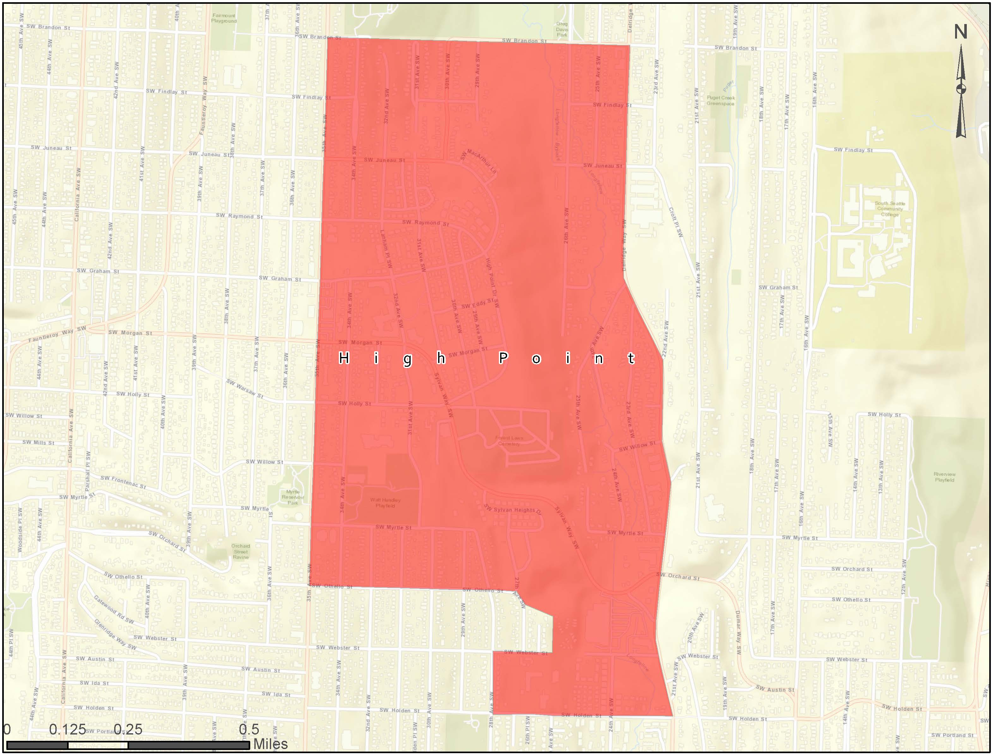

South Park is a 1.2-square-mile low-income neighborhood with a population of 5,421. Over 29 percent of the neighborhood’s residents live below the poverty level, which is more than twice the City average. The neighborhood’s median household income, $46,593, is one-third lower than the City median. The South Park district is surrounded by the City’s industrial area and has suffered from a long history of air and water pollution. The neighborhood is the center of the City's Hispanic community, with a population that is 42 percent Latino, compared to 6.6 percent citywide. From its founding at the turn of the 20th century, South Park was unable to secure adequate water services. Today, its residents still suffer from inadequate access to utilities, as low-income, minority residents remain least likely to be connected. Through the Digital Equity Initiative, the City seeks to reverse this history of inadequate services for historically underrepresented residents, such as those that live and work in South Park.
Figure 4: South Park
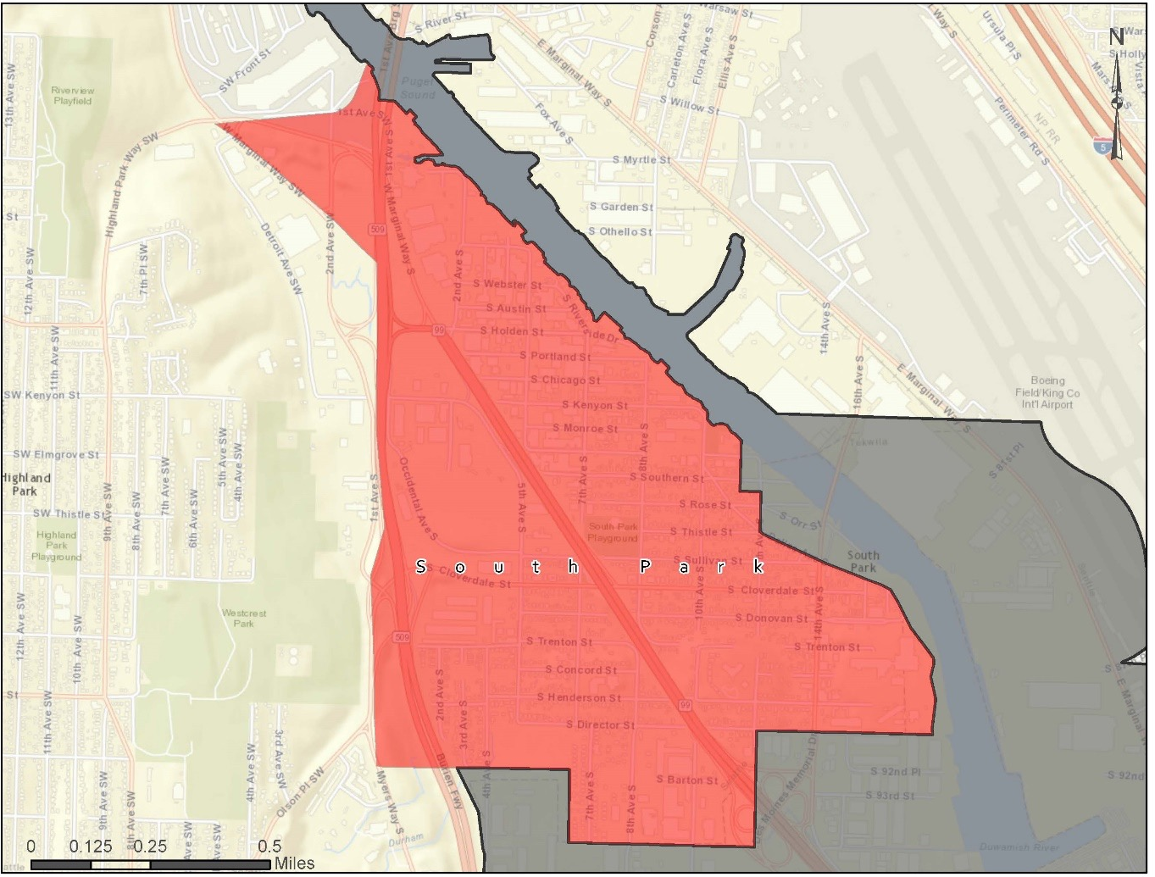
Rainier Vista is another area of the City where the HOPE IV grant helped to initiate redevelopment. Rainier Vista is one of the most diverse areas in the country, it is one of the communities that makes up the Rainier Valley district, where over 59 different languages are spoken. The area straddles Martin Luther King Jr Way S, one of the City’s major traffic corridors. It is also adjacent to the Columbia City LINK station, a stop along the City’s light rail system which provides services to downtown and the Sea-Tac Airport. The district offers several amenities for low-income residents including a Boys & Girls Club and a branch of Neighborhood House, a nonprofit organization that provides social services. In an effort to keep the redeveloped district open to all income levels, 251 units designated for public housing were set aside for residents with incomes of 30 percent or lower than the AMI, as were 226 units of affordable rental housing and 211 units of for-sale housing for residents with incomes of 50 percent or lower than AMI.
Figure 5: Rainier Vista
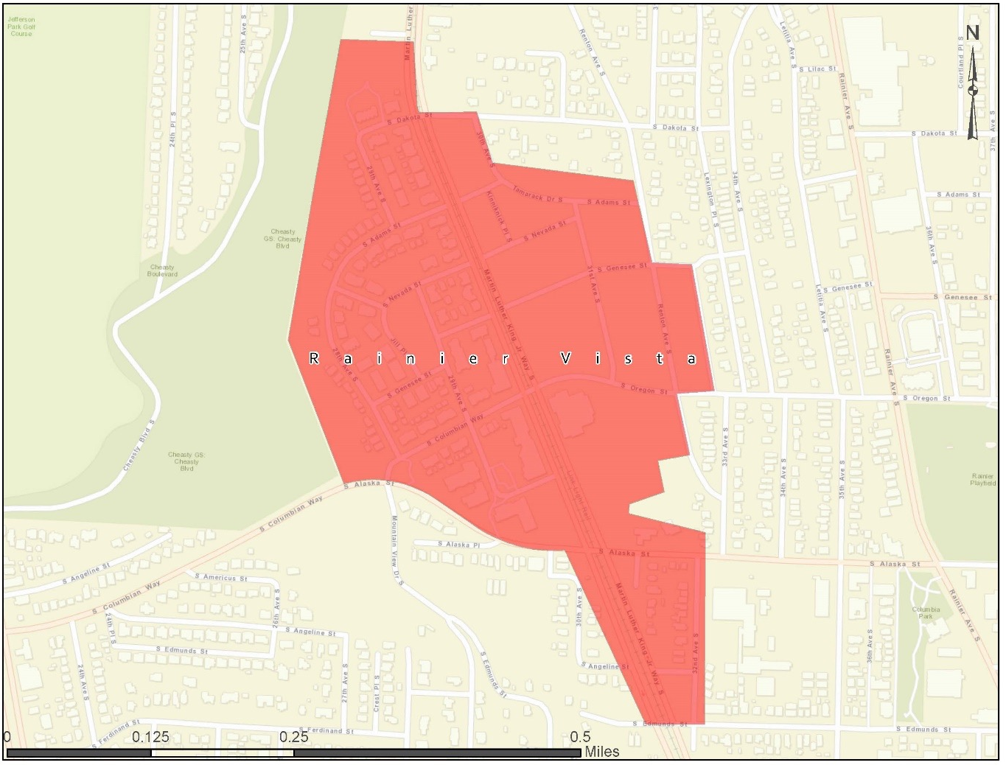

The Othello urban village is a destination for immigrants and refugees. It is a diverse area with residents speaking more than 40 different languages. The district serves as an “incubator” for a diverse selection of family-owned small businesses, many of which run along the Martin Luther King Jr Way S, a heavily trafficked corridor in the City. In 2009, a LINK station was built in the district providing residents with light rail service to downtown Seattle and the Sea-Tac airport. The addition of the light rail has brought new economic development to the district and an influx of new residents.
Figure 6: Othello
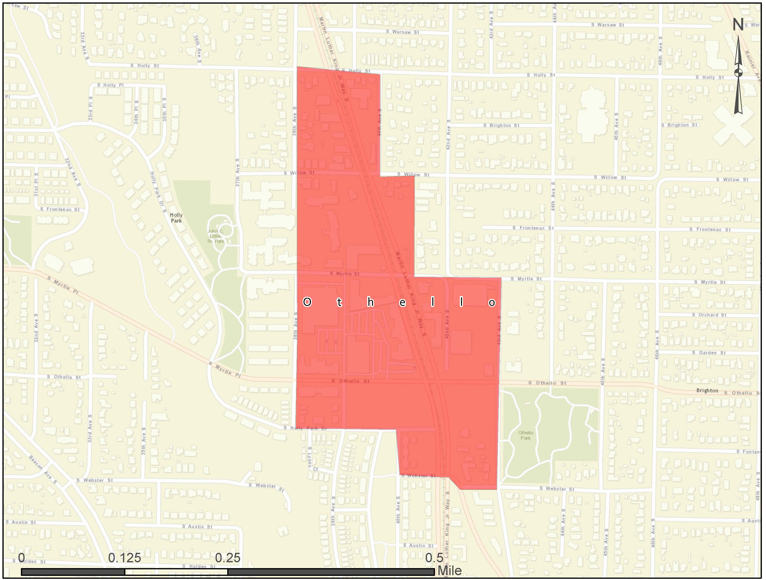

Rainer Beach is home to a diverse population of more than 5,000 residents. Rainier Beach is also one of the poorer neighborhoods in southeast Seattle with 21.8 percent of family households and 31.5 percent of non-family households living in poverty. The neighborhood is comprised of four key areas where residents tend to gather and shop: Rose Street, Beach Square, Station Area, and the Historic Business District. Improvements are being made in each of these core areas to revitalize them and the neighborhood as a whole.
Figure 7: Rainier Beach
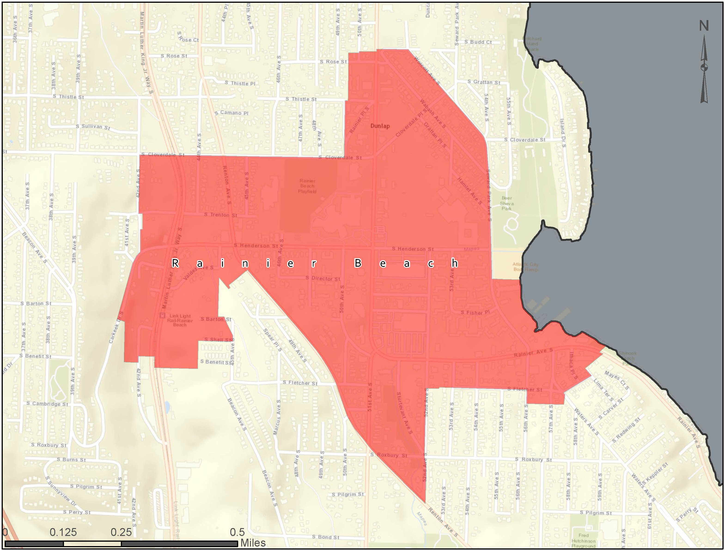

The Lake City urban village is an area of the City that currently targeted for improvement. On February 10, Mayor Murray announced that the City’s Office of Planning and Community Development would work with the Lake City community to achieve their shared vision for the neighborhood. The community improvements will focus on economic development, transportation, housing, and human services. Specific improvements include better vehicular and pedestrian access within the community, additional housing for all income levels, and implementing strategies to create a healthy business district.
Figure 8: Lake City
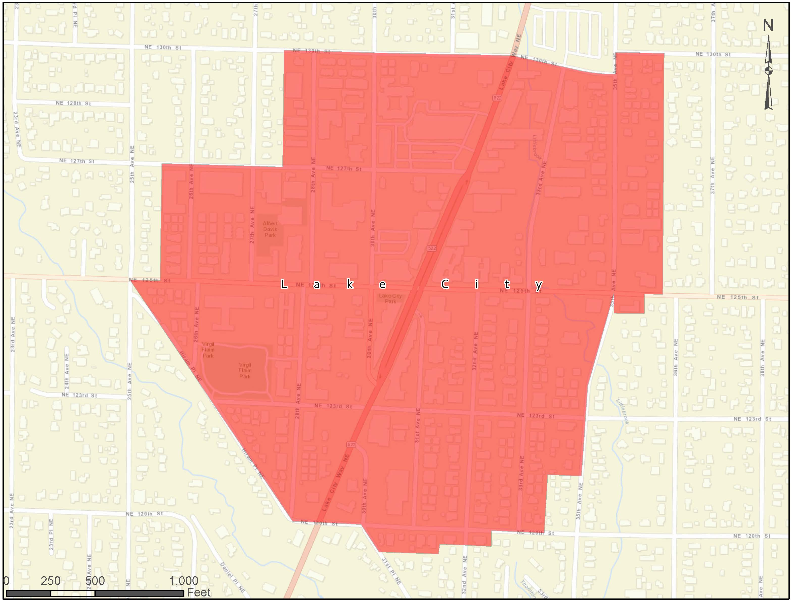

The SW Roxbury Street Corridor runs along the southern border of Seattle between the Westwood-Highland Park urban village and the City of White Center. White Center is a diverse community with approximately 32,000 residents. The 2010 census revealed that City’s population was 24.4% Asian and Pacific Islander, 21.5% Latino, and 8.6% African American. The Westwood-Highland Park Urban Village was created in the 1990s in an attempt to revitalize the area and has initiated growth and change to the area.
Figure 9: Roxbury Street Corridor
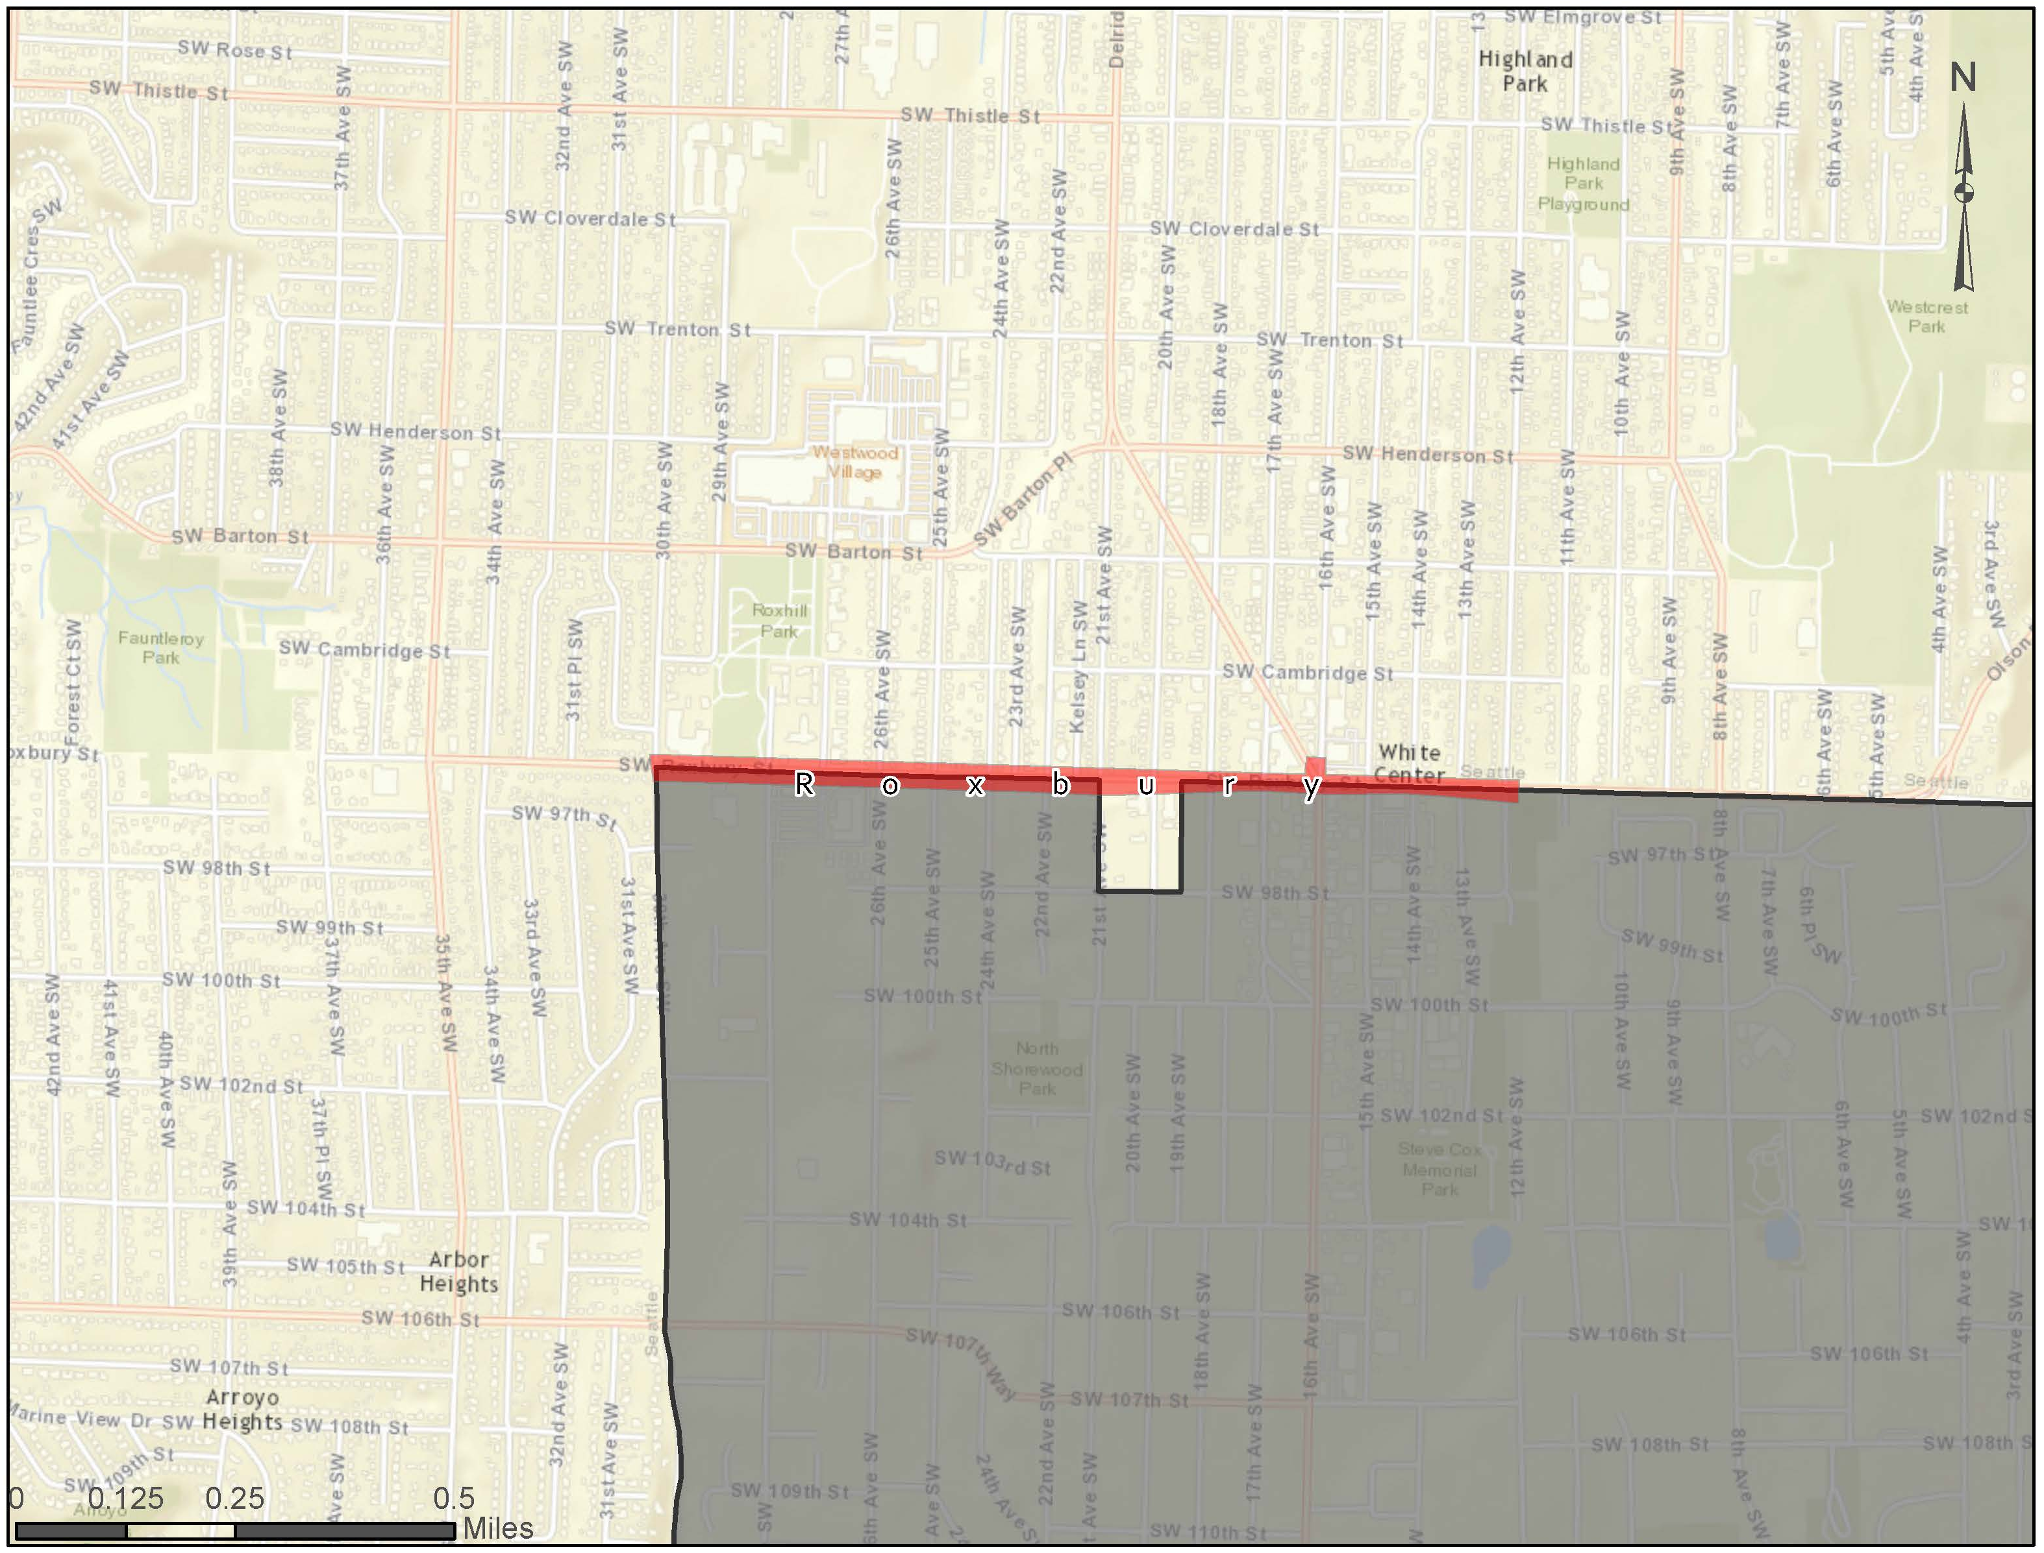

23rd Avenue is a highly traversed corridor in the Central District, which connects three important community locations at the cross streets of Union, Cherry and Jackson. The corridor contains many business and institutions that are central to the African American community in Seattle. 23rd Avenue is currently undergoing road construction to increase usability and safety in the corridor as part of a larger action plan to revitalize the area.
Figure 10: 23rd Ave Corridor (Central District)
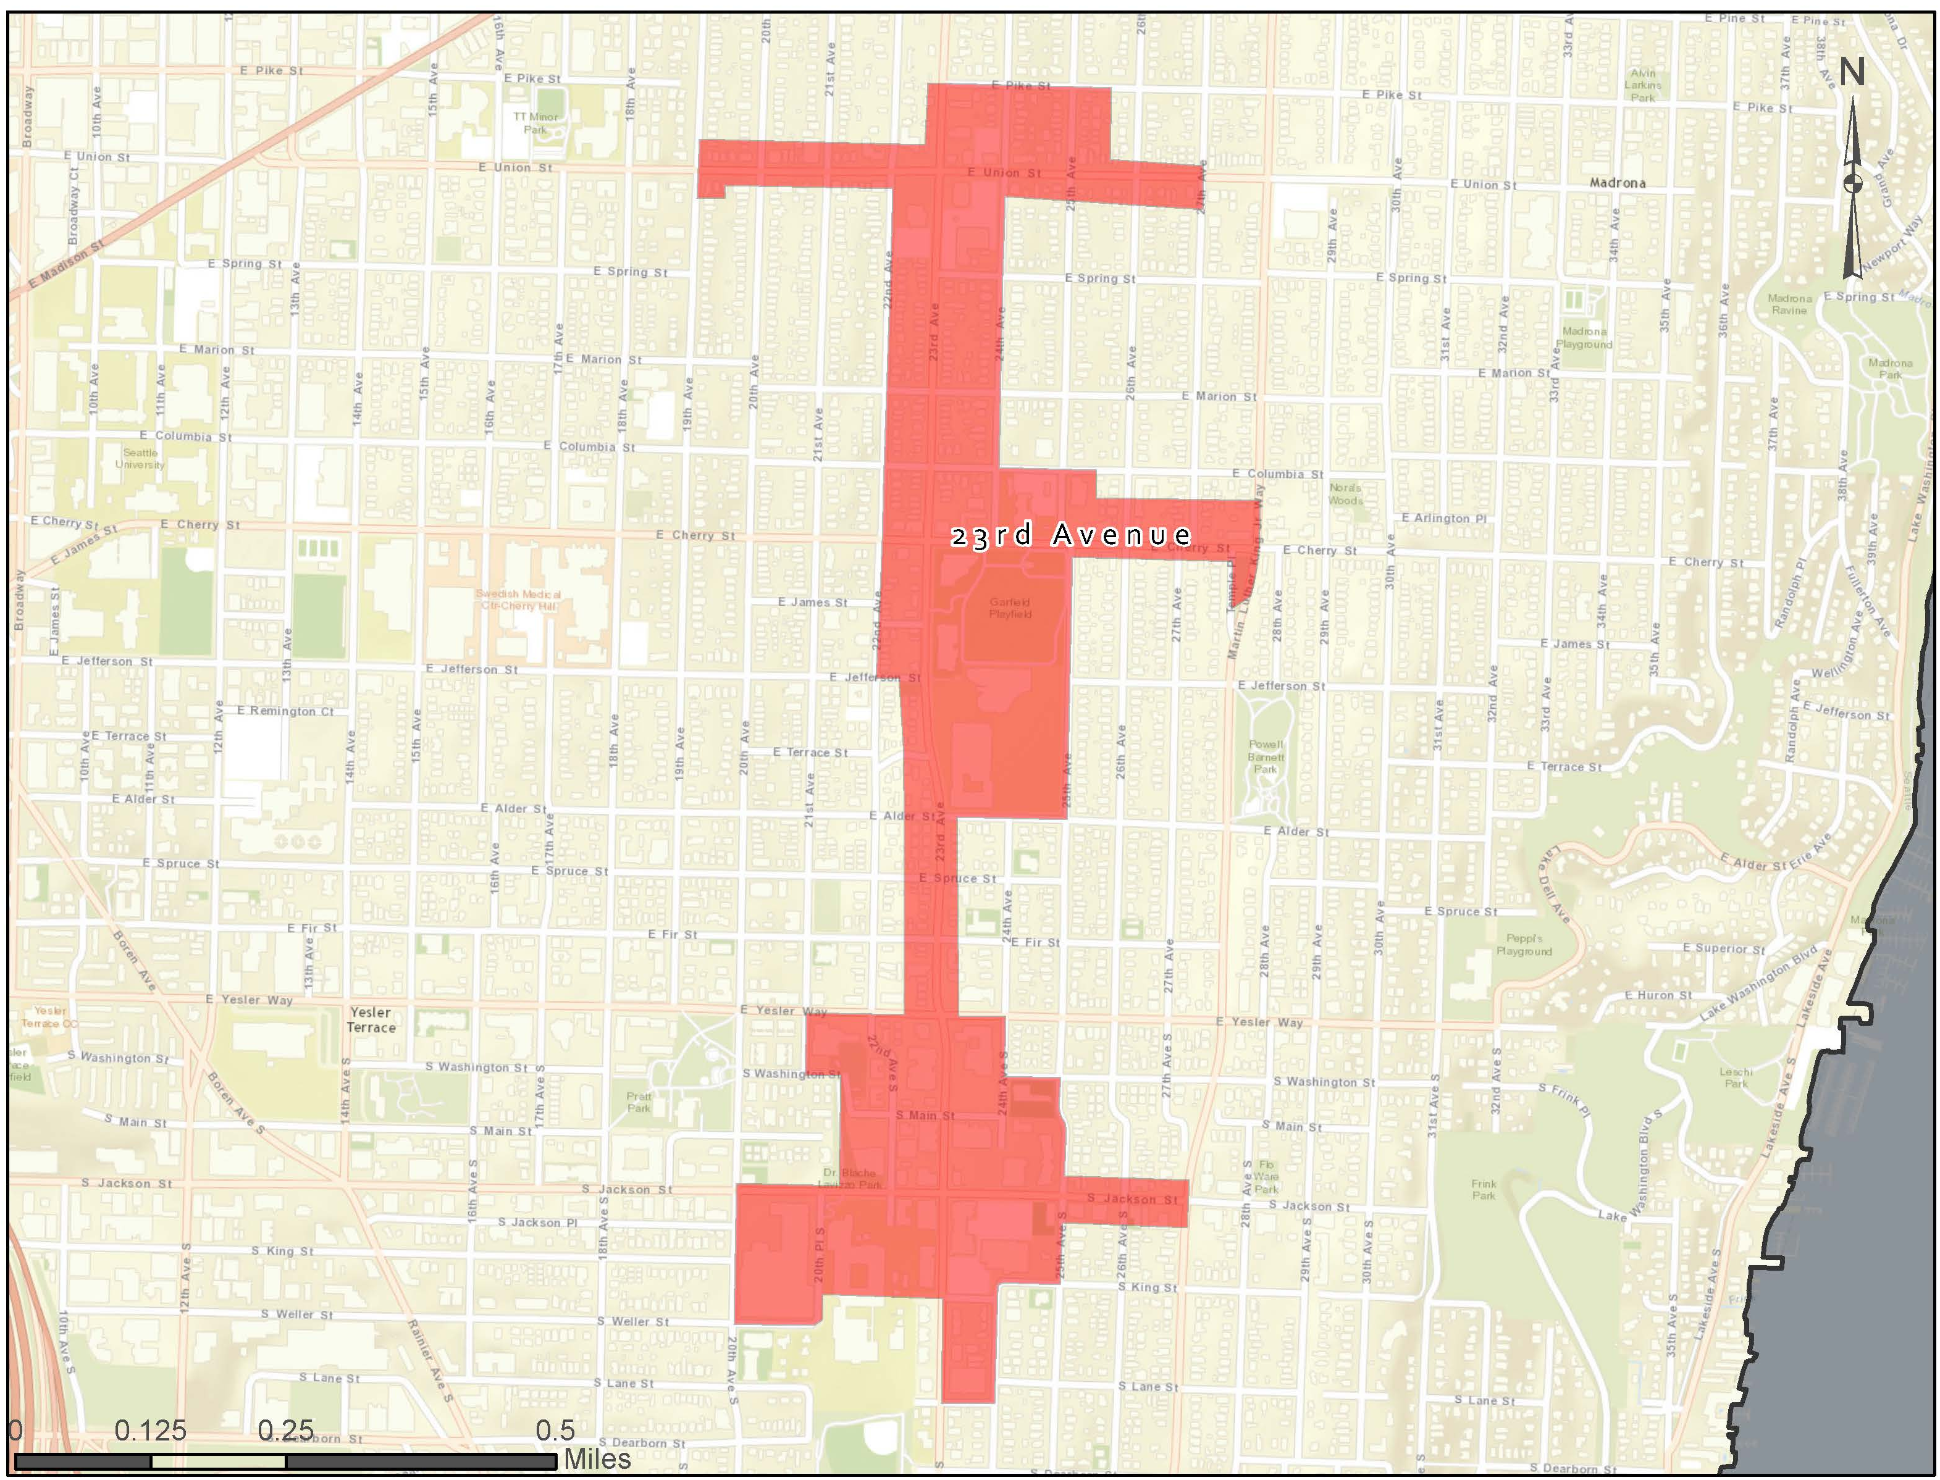

Judkins Park is located within Seattle’s Atlantic neighborhood, one of the oldest neighborhoods in the City and only two miles from downtown. Highway construction during the 1960s through the early 1990s led to significant disruption in the neighborhood, preventing its economic growth. The area is racially diverse, with a majority minority population. Today, the area houses a number of social services agencies providing resources to City residents for struggling with homelessness, addiction, blindness and poverty. Its proximity to a network of green belts and trails make it an ideal location for connectivity.
Figure 11: Judkins Park
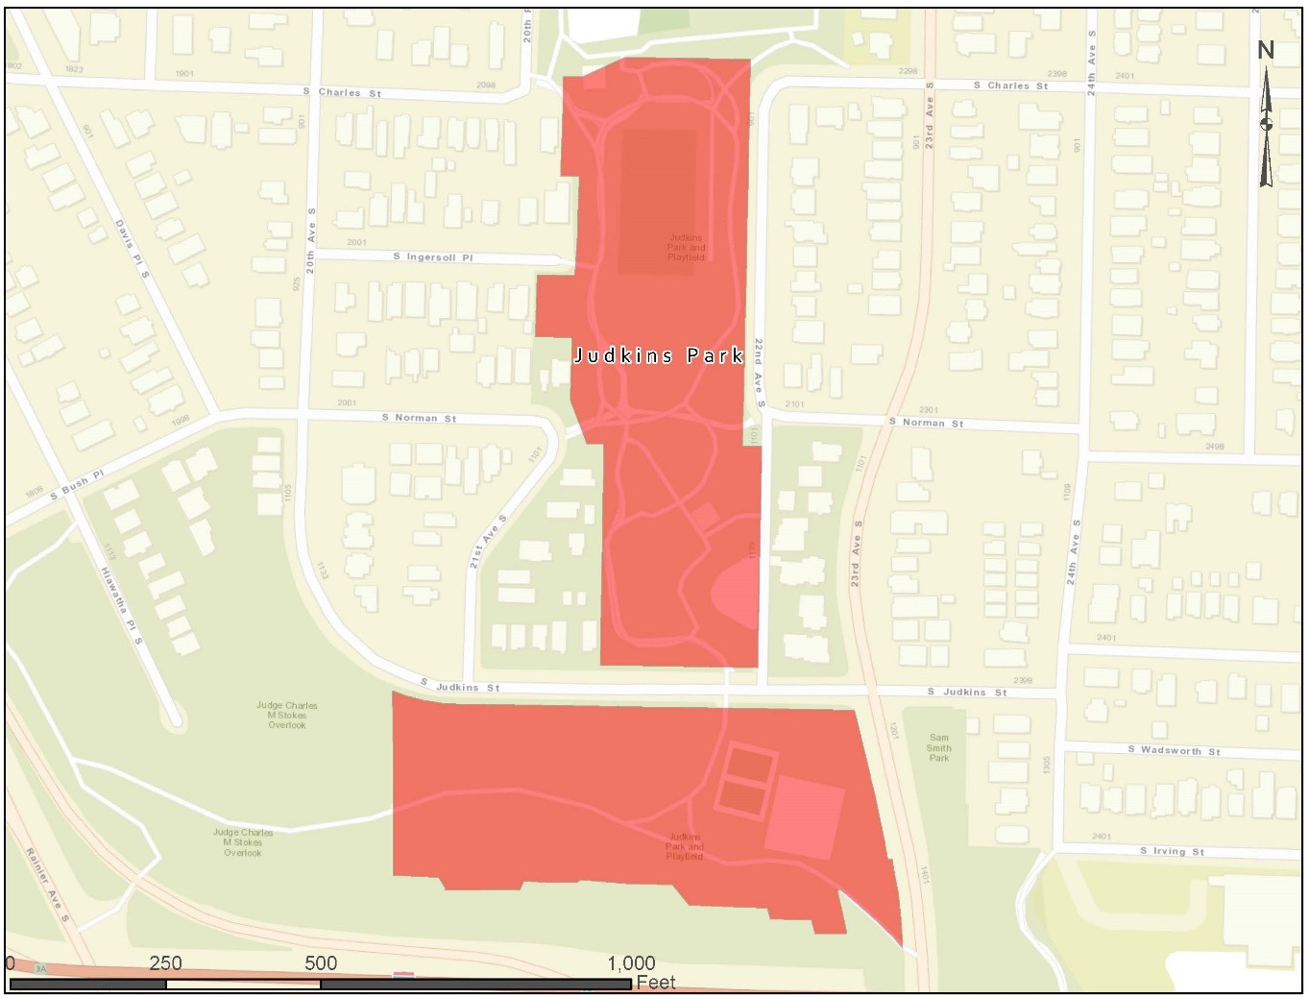

Jimi Hendrix Park is a two-and-a-half acre stretch of land in Seattle's Central District. The Central District has long been one of the City’s most racially and ethnically diverse neighborhoods. Today, the neighborhood is home to nearly 30,000 residents. Construction of Jimi Hendrix Park was completed in summer 2016. The park is envisioned as a gathering place for people of different backgrounds to explore music and art and celebrate Seattle's cultural heritage. Rosanna Sharpe, executive director of the adjacent Northwest African American Museum said, “This destination shines brightly in the cultural landscape and serves as a beacon for the new formed Historic Central Area Arts & Cultural District.” As a central gathering place, the park is a priority area to provide public connectivity for residents and visitors.
Figure 12: Jimi Hendrix Park
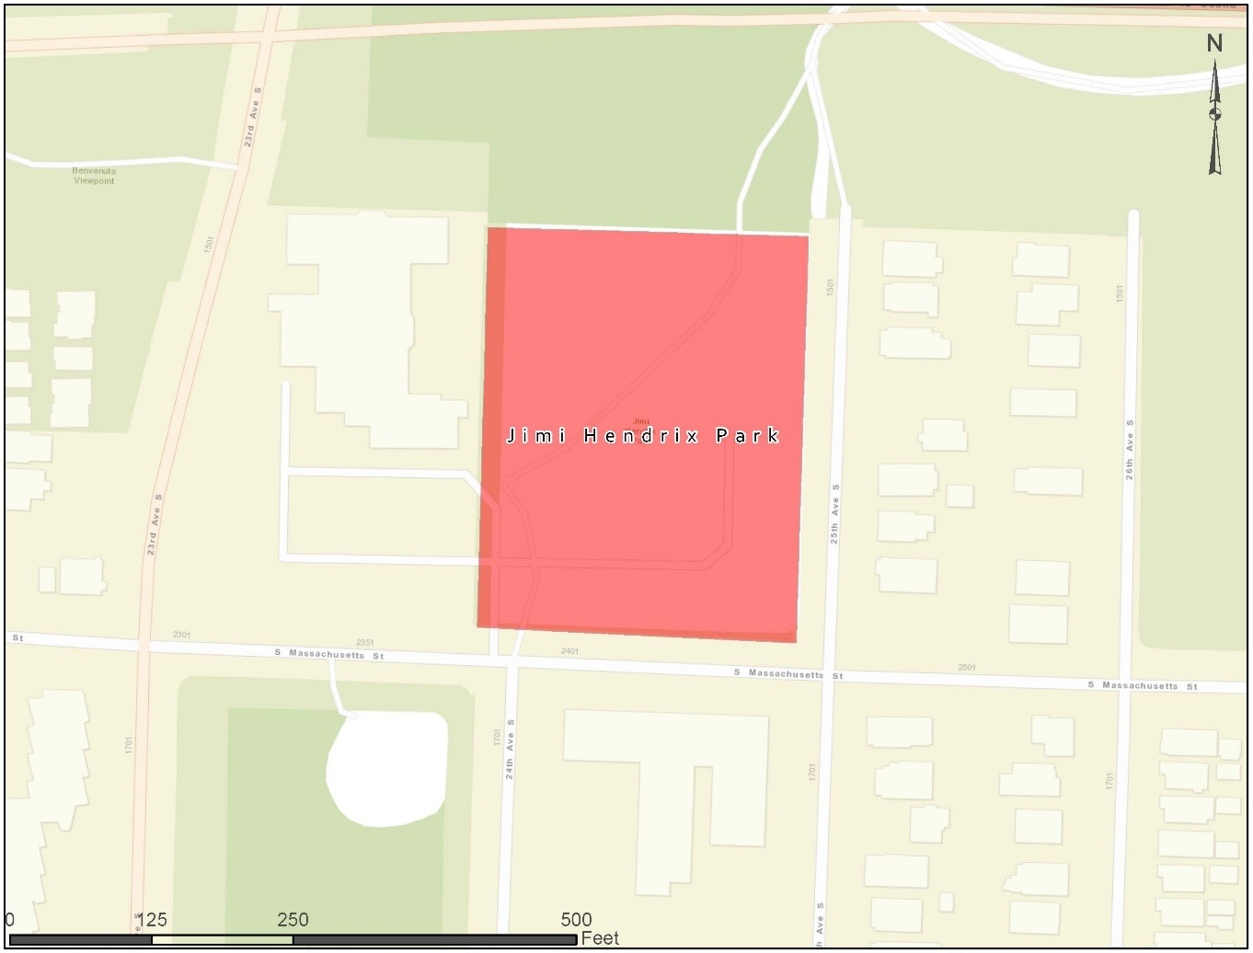

Pratt Park was established to provide open space adjacent to a low-income housing project. Wireless access in this public space will provide critical connectivity to residents. The park features picnic tables, benches, a play area, a spray park, a basketball pavilion, a grassy area and an open field.
Figure 13: Pratt Park
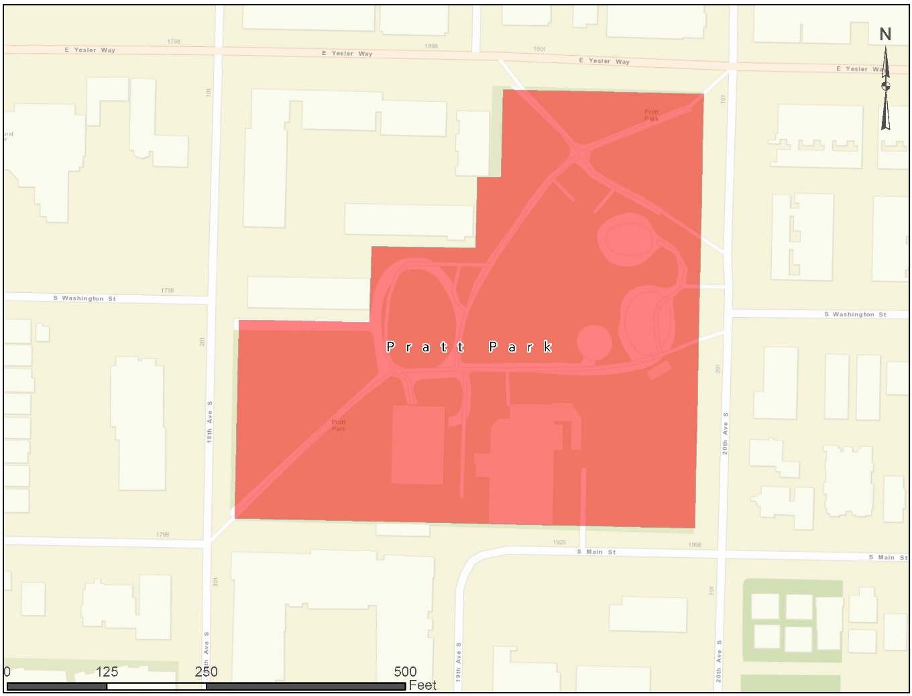

City Parks
Warren G. Magnuson Park, located in the Sand Point neighborhood, features a range of amenities including sports fields, a community garden, a swimming beach and over four miles of walking trails. The park was formerly a military base and has many landmarks and historical sites, its “historic district” features more than 20 structures built in the 1930’s and 1940 including Building 30, a former airplane hangar that has been recently renovated. The hanger is a key component of the park as it is often rented out for special events, many of which feature merchants selling wares. The current issue the park faces with the event space is the lack of cellular signal in the building, this is impeding the merchant’s ability to use Square and other kinds of financial transaction software on mobile devices. The geography and historical nature of the park pose barriers for wireless coverage.
Figure 14: Magnuson Park
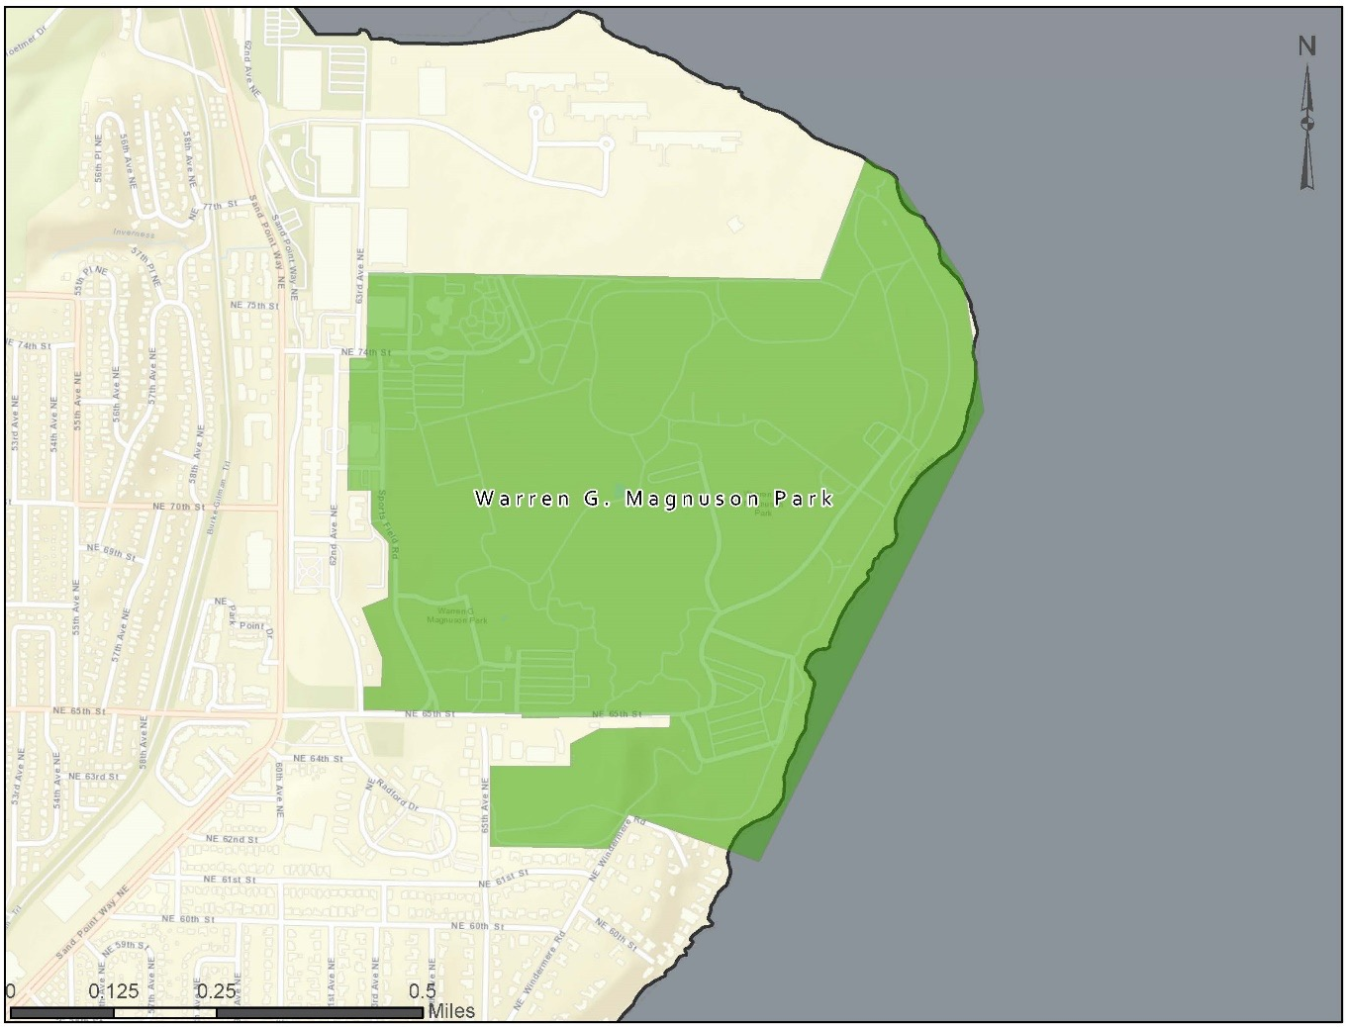

Camp Long, located in West Seattle, is a 68-acre park offering a range of amenities that allow visitors to hike trails, camp overnight in cabins, rock climb and learn about natural history. The park offers rentals of its facilities including a lodge with a meeting room, kitchen space, 10 cabins, two covered picnic areas, a group fire ring and a climbing rock. Park staff conduct environmental learning courses throughout the year. The addition of wireless access would improve the park’s learning courses and would make its available amenities become more desirable. The geography of the park may pose interesting barriers for wireless coverage at the extremities of the park property.
Figure 15: Camp Long
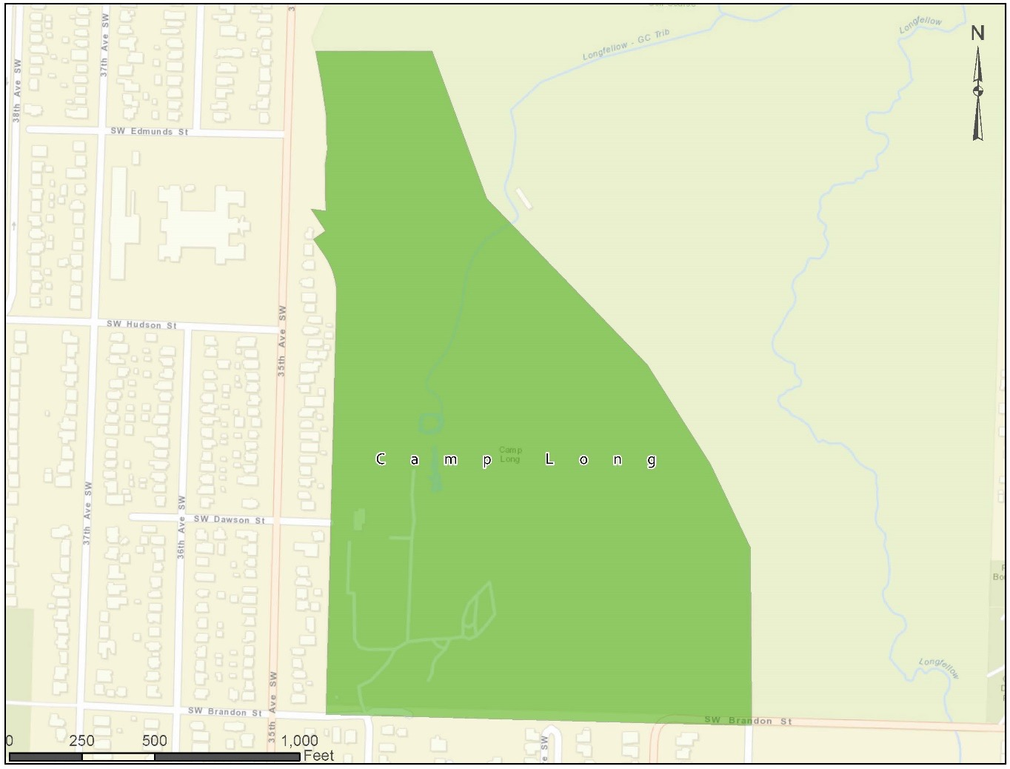

Discovery Park, located in the Magnolia neighborhood, is a 534-acre park situated along the northwestern edge of Magnolia Bluff overlooking the Puget Sound. The park offers environmental courses throughout the year. The Discovery Park Environmental Learning Center is also located in the park and provides programs to enhance the learning experience. The park is also used to hold ceremonies such as weddings and other special events. The addition of wireless access would improve the park’s learning courses and would enhance the quality of the special event space.
Figure 16: Discovery Park
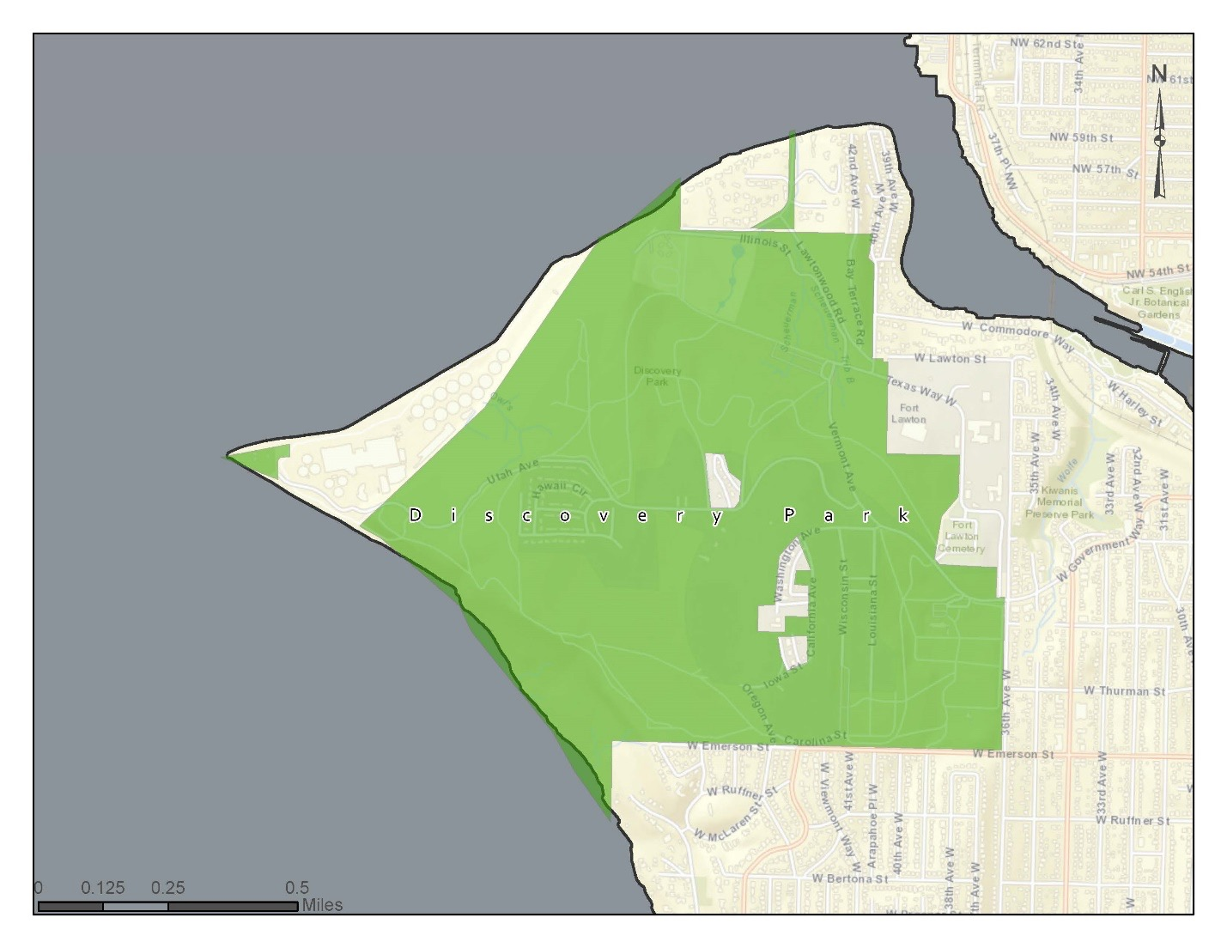

Westlake Park is located in the heart of Seattle’s retail district. Often considered the unofficial town square of Seattle, the park’s location attracts thousands of people each day. Extensive programing for the park is provided by the Downtown Seattle Association (DSA) and activities occur year-round on almost daily a daily basis. Some of the amenities the park provides include bistro-style seating, food trucks, fitness classes, ping pong, foosball and a reading room. Wireless access would provide another useful amenity for the public and enhance the parks scheduled activates.
Figure 17: Westlake Park
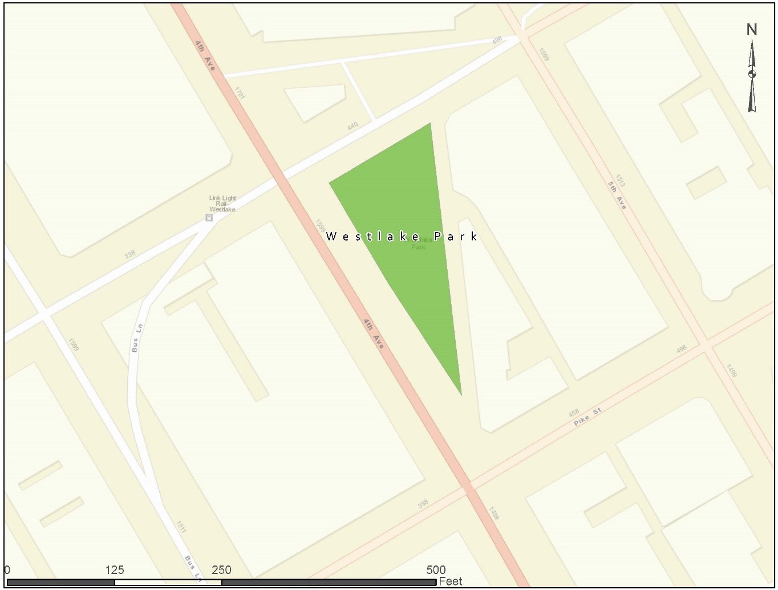

Occidental Square is located in Seattle’s historic Pioneer Square district. Activities are provided year around by the DSA. The Park’s amenities include bistro-style seating, food trucks, fitness classes, refurbished bocce ball courts and a reading room. Wireless access would provide another useful amenity for the public and enhance the parks scheduled activates.
Figure 18: Occidental Square
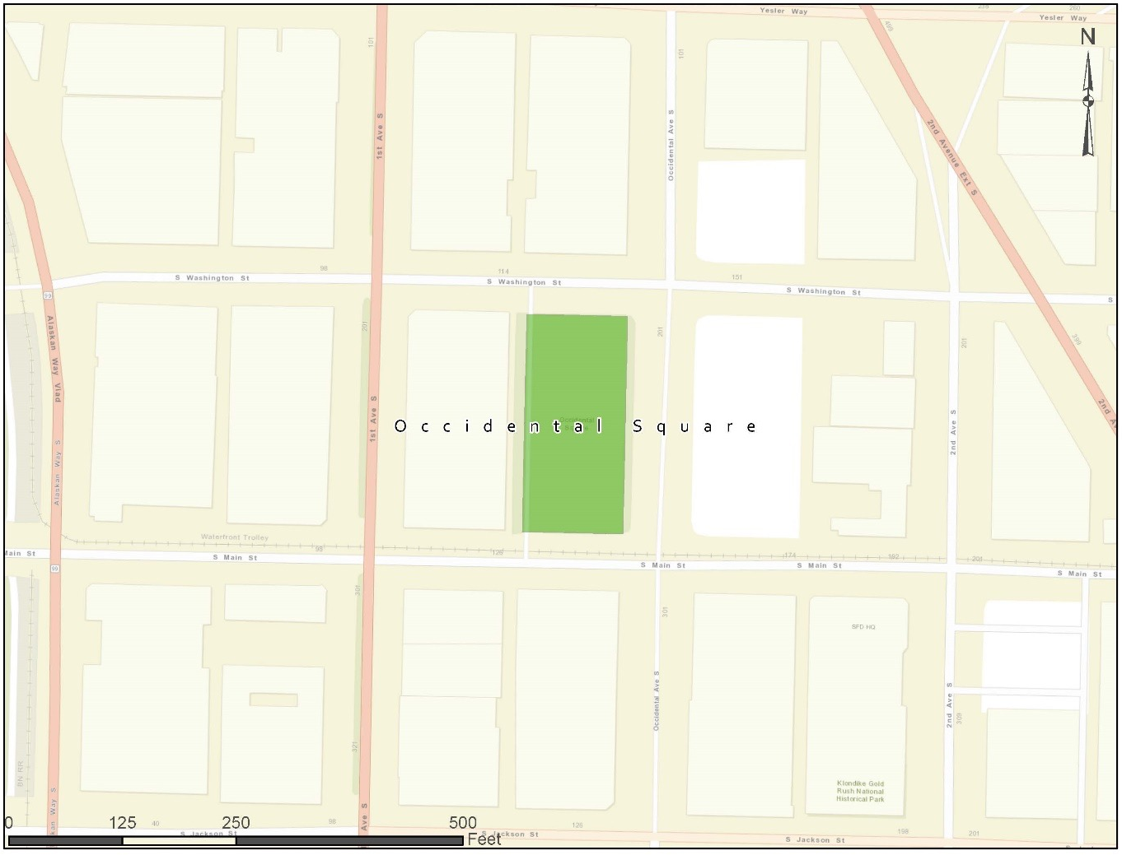

Waterfront Park is located between Pier 57 and Pier 59. The park features scenic views of the city skyline, Magnolia Bluff, the West Seattle Bridge, the Seattle harbor and Bainbridge Island. The park amenities include picnic tables, ping pong, access to the Seattle Aquarium and the “Great Wheel” a 175-foot-tall Ferris wheel overlooking the Puget Sound. The park is within walking distance to Pike Place Market, one of the City’s major attractions. Wireless access would provide another useful amenity for the public.
Figure 19: Waterfront Park
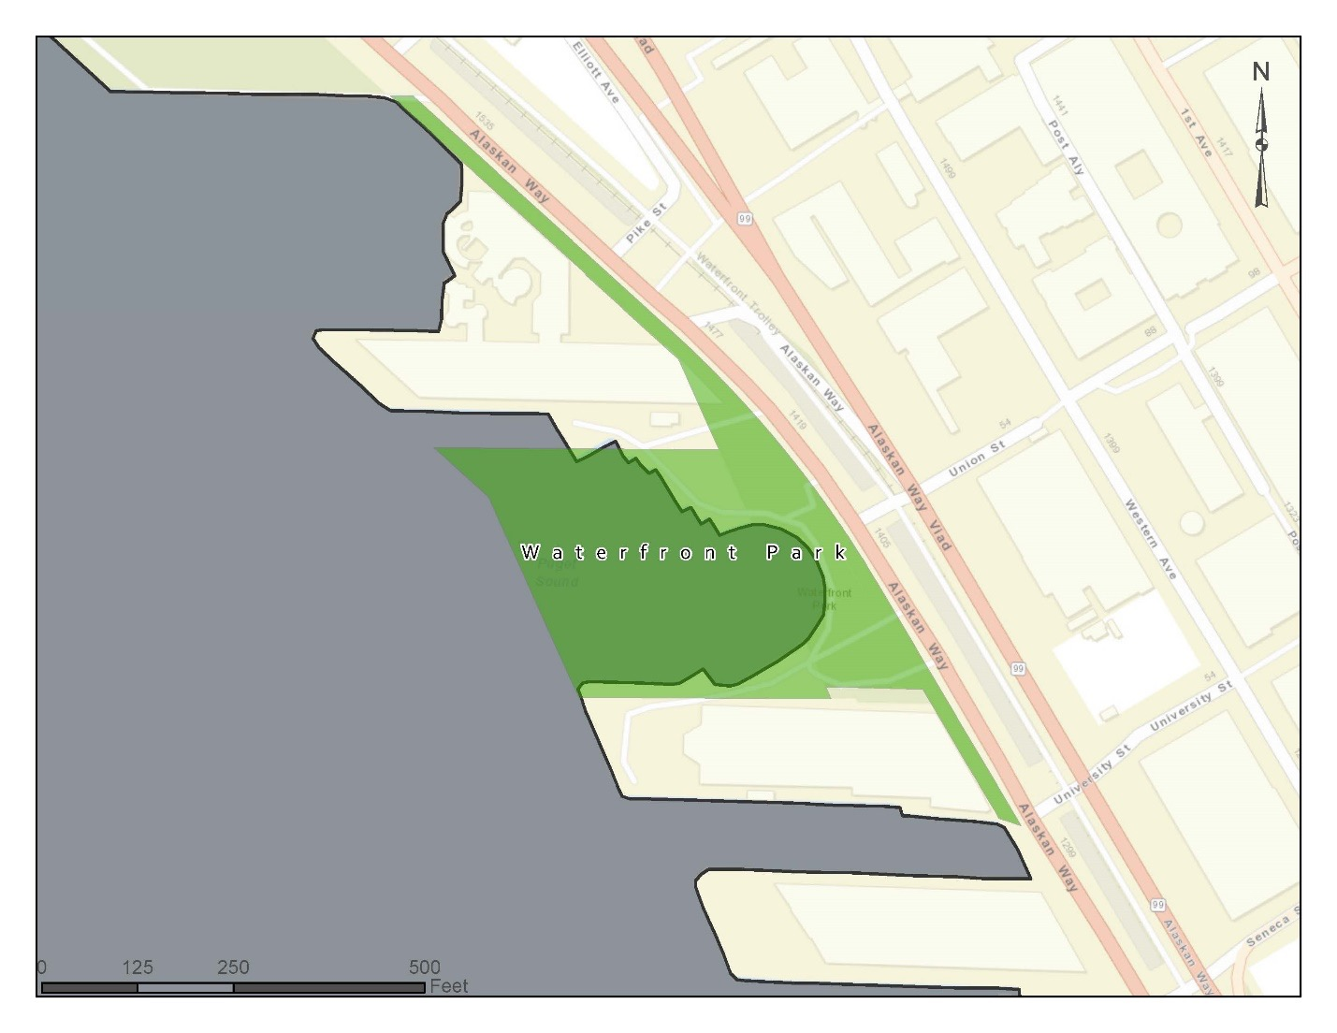

City Contributions and Assets
The City will work with respondent(s) to determine how and whether City-owned light and traffic poles could be leveraged to mount wireless equipment. The City will work with respondent(s) to identify the terms and conditions of using City-owned light and traffic poles. While the City-owned poles have power, they most likely lack sufficient power to support the addition of wireless equipment without costly upgrades. However, the City is currently performing an ongoing project to convert its traffic lights to LEDs; the City is interested in learning more about potential joint construction opportunities or coordination efforts that could be leveraged to reduce the cost of deploying equipment on light and traffic poles.
The City will work with respondent(s) to determine how and whether Seattle City Light (SCL) utility poles could be leveraged to mount equipment and provide a power. The City will work with respondent(s) to identify the terms and conditions of using SCL utility poles. Please see Appendix C for the location of all SCL utility poles in the City.
The City will work with respondent(s) to determine how and whether Seattle government buildings and structures, including rooftops of public housing operated by the Seattle Housing Authority (SHA) and bus shelters operated by King County, could be leveraged to mount wireless equipment and provide power. The City will work with respondent(s) to identify the terms and conditions of using government buildings, structures, and property. Please see Appendix D for the location of City-owned property and usable public buildings. Please see Appendix E for the location of King County bus shelters.
The City will work with respondent(s) to determine how and whether portions of the City’s 550-mile fiber network could be leveraged to connect devices and support a wireless deployment. The City will work with respondent(s) to identify the terms and conditions of using City-owned fiber. Due to the complicated nature of its fiber network, the City will need to evaluate the availability of its fiber on a case-by-case basis.
While the City has an expansive fiber footprint, the deployment was often purpose-driven, resulting in many point-to-point routes that do not interconnect to traverse the City. An additional barrier to using the City’s existing fiber is its ownership structure. The City’s fiber is owned by a consortium of 20 separate government entities, including King County and the federal government. Each individual fiber route belongs to a subset of the 20 entities who participated in the financing of the route. Given the ownership and governance complexities, some fiber routes are limited to only government functions. Providers would only be able to access portions of the fiber network where these specific restrictions do not apply.
Additionally, the City’s fiber in downtown Seattle leverages spare conduit provided by telecom service providers and may have restrictions limiting the fiber’s use to governmental purposes. This may restrict the ability of the respondent to leverage City fiber to reach downtown data centers and co-locations spaces.
The City has identified the potential for availability of its fiber in the individual priority areas listed in Section III of this document. This information can be found in Appendix F. For areas where the City fiber is unavailable, the City will work with respondent(s) to determine how and whether space on the utility poles normally reserved for governmental use would be made available. The City will work with respondent(s) to identify the terms and conditions of using governmental space on utility poles.

RFI Response Requirements
The City of Seattle requests the following information—in as much detail as is practicable—from respondents. We ask that all responses please adhere to the following response requirements and page requirements. All responses must follow the exact order below and use the appropriate response headers. Start a new page for each response header.
  - Cover Letter: Please include company name, address of corporate headquarters, address of nearest local office, contact name for response, and that person’s contact information (address, phone, cell, email, other). Keep response to one (1) page.
  - Business Structure: Summarize the business approach you would use for the project and describe what areas of the City this approach would apply to. How would your business plan help to meet the City’s goals? What are the key assumptions? What are your main areas of risk, and how can the City help reduce the risks? Keep response to no more than three (3) pages.
  - Summary of Business Model: Summarize the business model you intend to use for the partnership. This should be a concise explanation of the key components of your business model, including but not limited to the division of network and operations responsibility and ownership. Keep response to two (2) pages.
  - Summary of Technical Approach: At a high level, summarize the technical approach you would use for this project.
    - How would you use technology to meet the City’s goals? Keep response to one (1) page.
    - What approach would you use to interconnect with the Internet and other public networks? Keep response to one-half (½) page.
    - Provide proposed network diagrams. Keep response to one (1) page.
  - Summary of Operational Approach: At a high level, summarize the operational approach you would use for this project.
    - Describe the nature of the service and the connection speeds. Keep response to one-half (½) page.
    - Describe how the public would access the public wireless service (e.g., would individuals have to accept terms on an access portal before they could connect?). Keep response to one-half (½) page.
    - How would you perform network management? Keep response to one-half (½) page.
    - What would be the recurring costs for the service and how would those costs be paid for? What are the key technical assumptions upon which these costs are based? If payments would be through advertisements, would the advertisements be part of connecting to the network or simply on the network’s hardware deployed in the City? Keep response to two (2) pages.
    - Describe how network capacity would be allocated among the City, the public, and your company. If some capacity would be reserved for your company, describe how that capacity would be used. Keep response to one (1) page.
  - Schedule: Describe your proposed schedule for implementing service. Offer a timeline with key milestones. Keep response to two (2) pages (one for response, one for schedule).
  - Maintenance: If you are proposing to perform network maintenance, describe your ability to perform maintenance on an ongoing and as-needed basis. Provide estimates of the operating cost of maintaining the networks and include your main assumptions. If you are not performing maintenance, who is? Keep response to one (1) page.
  - Data Privacy, Security, and Ownership: Describe your ability to provide secure network service or infrastructure that complies with the City’s privacy regulations and requirements (https://www.seattle.gov/tech/initiatives/privacy). Describe whether the data transmitted over the networks would be owned by you or the City. Keep response to one (1) page.
  - Financing and Funding: Discuss how you intend to fund the project development. To successfully answer this question, list any requirements the City must meet for you to partner with the City on this project. If you do not address this question, it will be assumed that you are interested in the partnership but have no financial requirements whatsoever of the City. You should address both financial and in-kind contributions to the project development, how you intend to finance the project, and from what sources you may obtain financing. Discuss any payments the City or other parties may have to make to support the service. Please also provide a one-page flow chart that shows the flow of funds between all parties in your response. Include all sources and uses of funds. Also discuss how your business model would maximize any contributions and investment. Keep response to two (2) pages, plus the one-page flowchart.
  - Role of Public and Partners: Describe your roles and the roles of the City in deploying and operating the network. Would you be a turnkey carrier, capacity provider, or construction partner? Keep response to one (1) page.
  - Term Length: If the partnership would be for a limited term, describe the anticipated length of the term and how the network would operate at the end of the term. Keep response to one-half (½) page.
  - Promotion: Describe how you would advertise the public wireless service to the public both on location and generally. Keep response to one (1) page.
  - Local Participation and Economic Development: Provide a statement of how your proposed participation would help the City’s economic development goals. Describe your interests and plans to hire local contractors and providers in the City of Seattle, and how your participation would help local job creation. Describe your relationships with local businesses in the City, if any, as well as your interest and plans to engage them in this project. Keep response to three (3) pages.
  - Affirmation: Affirm that you are interested in this partnership and address any other core project goals and requirements that were not already addressed in this section. Also describe any other potential services your model could support that were not specifically suggested by the City, and the costs of those services. If you cannot meet any of those requirements, indicate the requirements to which you take exception, and provide an explanation of the exceptions. Keep response to two (2) pages.
  - Experience: Provide a statement of experience discussing past performance, capabilities, and qualifications. Identify other networks your firm has designed, built, maintained, or operated; include the levels of broadband speed, availability, adoption or usage among different categories of end users, and unique capabilities or attributes. Discuss partnerships with other service providers, government, or nonprofit entities you have undertaken, particularly any involving wireless services. Describe the nature of the projects and your firm’s role. For entities currently providing communication services in or near Seattle, describe your current service footprint in the City, including a description of the type of infrastructure and services you currently offer and the technology platform(s) used. Explain how your firm is a suitable partner for this project. Keep response to two (2) pages.
  - References: Provide a minimum of three (3) references, including contact information, from previous contracts or partnerships. Keep response to two (2) pages.
Please provide two signed copies of the Non-Disclosure Agreement (Appendix A1).

Confidentiality and Personal Presentations
The State of Washington’s Public Records Act (Release/Disclosure of Public Records) Under Washington State Law (reference RCW Chapter 42.56, the Public Records Act) deems all materials received or created by the City of Seattle public records. These records include but are not limited to bid or proposal submittals, agreement documents, contract work product, or other bid material.
The State of Washington’s Public Records Act requires that public records must be promptly disclosed by Seattle IT upon request unless that RCW or another Washington State statute specifically exempts records from disclosure. Exemptions are narrow and explicit and are listed in Washington State Law (Reference RCW 42.56 and RCW 19.108).
As mentioned above, Seattle IT is required to promptly make public records available upon request. However, under Washington State Law some records or portions of records may be considered legally exempt from disclosure. A list and description of records identified as exempt by the Public Records Act can be found in RCW 42.56 and RCW 19.108.
If Seattle IT receives a public disclosure request for any records or parts of records that Proposer has properly and specifically listed as confidential in the Non-Disclosure Request Form (Appendix A1), Seattle IT will notify Proposer by email of the request and will postpone disclosure. While it is not a legal obligation, Seattle IT, as a courtesy, will allow Proposer up to ten business days to obtain and serve the City with a court injunction to prevent the City from releasing the records (reference RCW 42.56.540). If you fail to obtain a Court order and serve the City within the ten days, Seattle IT may release the documents.
Seattle IT will not assert an exemption from disclosure on Proposer’s behalf. If Proposer believes that its records are exempt from disclosure, Proposer is obligated to seek an injunction under RCW 42.56.540. Proposer acknowledges that Seattle IT will have no obligation or liability to Proposer if the records are disclosed. The City may invite respondents to conduct an individual and personal presentation to better explain information or solutions identified in their RFI response. These presentations will not be in lieu of an RFI response, unless at the request of the City. These presentations shall be held at a time and place of mutual convenience.

RFI Response Process

Questions
Questions related to this RFI should be emailed to Jeremy.doane@seattle.gov no later than 2:00 PM PT on 02/15/17.

Proposal Deadline
Final RFI submissions must be received in electronic form by 2:00 PM PT on 02/28/17. Please send the RFI response by email in PDF format to Jeremy.doane@seattle.gov. If your proposal contains information that is exempt under the State of Washington’s Public Records Act, please provide an additional redacted PDF.

Summary of RFI Process Deadlines
The following is the schedule for responding to this RFI. The schedule is subject to change:
01/30/17 – RFI released
02/15/17 @ 2:00 PM PT – Deadline for submitting questions
02/28/17 @ 2:00 PM – RFI responses due
The City of Seattle thanks you in advance for your thoughtful response.

Appendix A1: Non-Disclosure Agreement
Please provide two signed copies of the below Non-Disclosure Agreement.

Appendix A2: Non-Disclosure Request Form

Appendix B: City of Seattle Traffic Pole Locations and
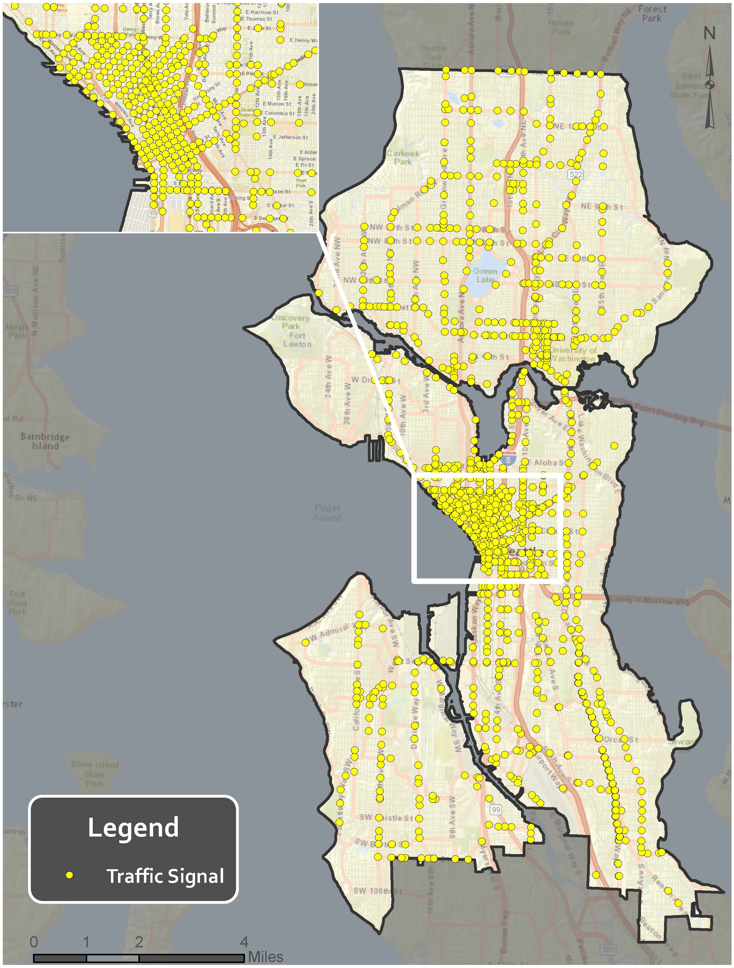

Appendix C: Removed

Appendix D: City of Seattle Property Locations
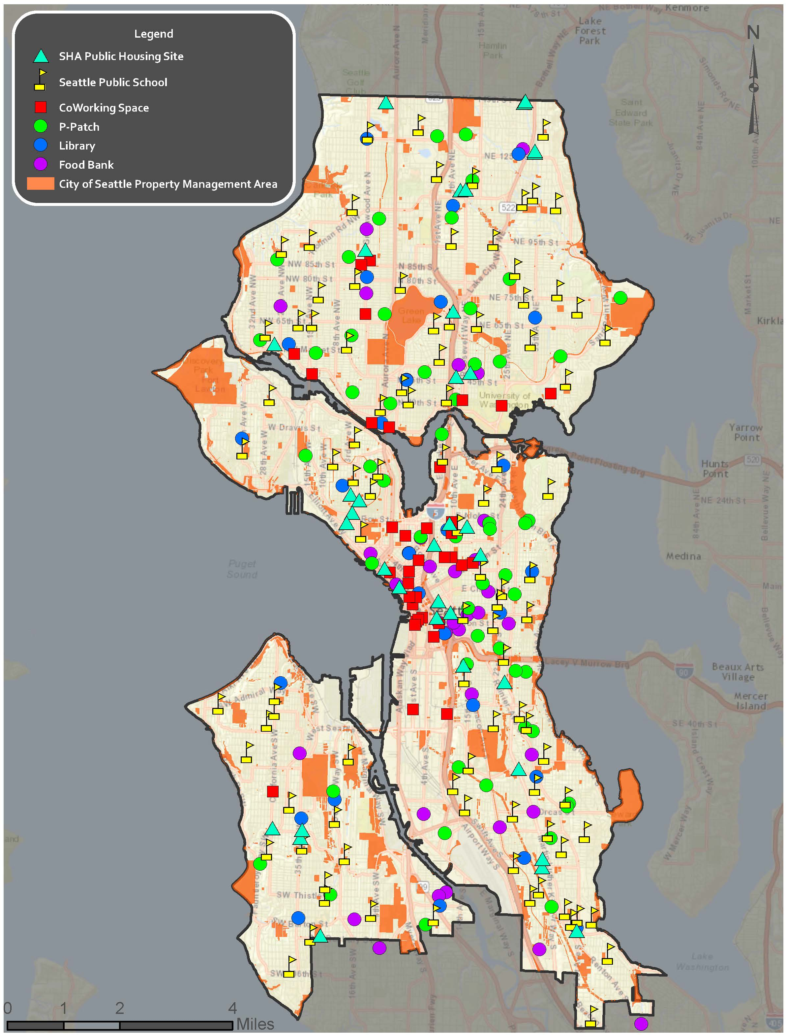

Appendix E: King County Bus Shelter Locations
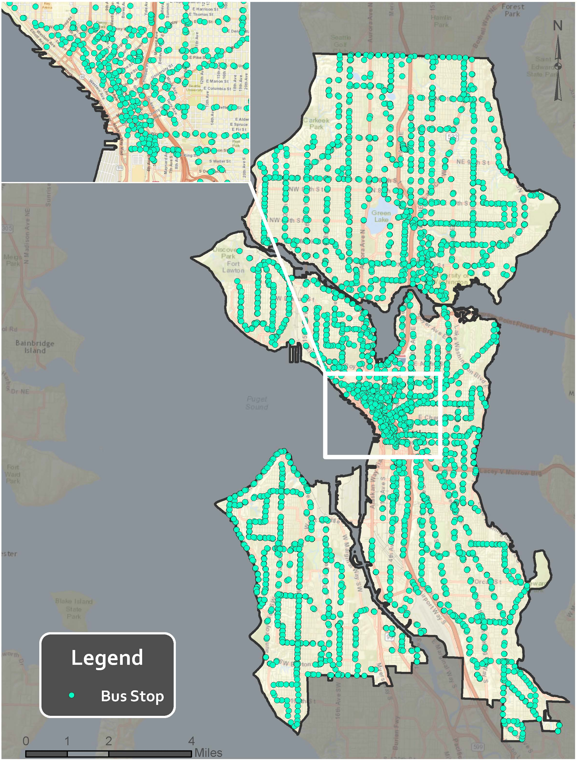

Appendix F: Fiber Availability in Priority Areas
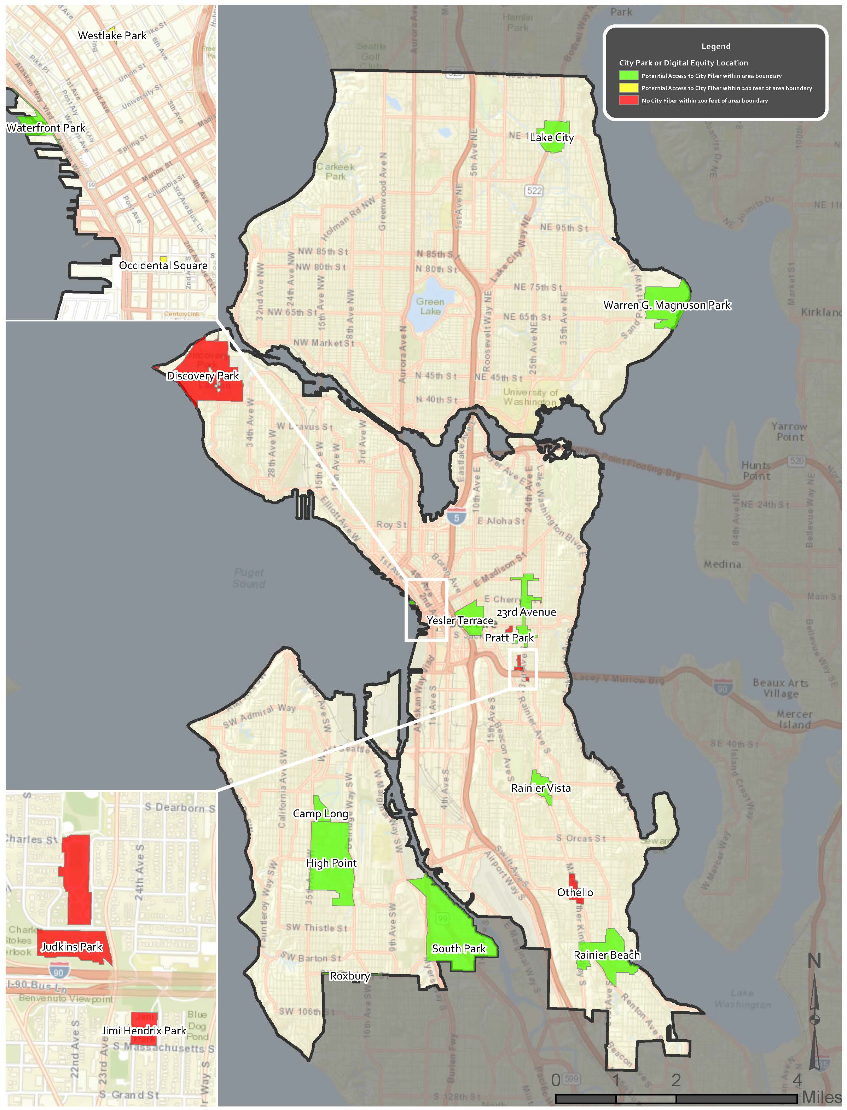

http://www.seattle.gov/dpd/cityplanning/populationdemographics/default.htm
http://www.downtownseattle.com/files/file/Demographics2011_WEB.pdf at 2
https://ballotpedia.org/Seattle_Public_Schools,_Washington
https://www.seattleschools.org/students/support/english_language_learners/
http://www.seattle.gov/dpd/cityplanning/populationdemographics/aboutseattle/prosperity/default.htm
http://www.seattle.gov/Documents/Departments/Tech/DigitalEquity_PhaseII.pdf at 24
http://www.seattle.gov/Documents/Departments/Tech/DigitalEquity_PhaseII.pdf at 8
Renewing Yesler’s Promise, Seattle Housing Authority, http://seattlehousing.net/wp-content/uploads/2016/02/Final-8-page-brochure-revised-2-2.pdf (accessed September 19, 2016).
Seattle’s High Point Redevelopment Project, United State Department of Housing and Urban Development, https://www.huduser.gov/portal/casestudies/study_04092012_1.html (accessed September 19, 2016).
High Point Redevelopment Plan, Seattle Housing Authority, https://www.seattlehousing.org/redevelopment/high-point/plan/ (accessed September 19, 2016)
http://www.city-data.com/neighborhood/South-Park-Seattle-WA.html
http://statisticalatlas.com/neighborhood/Washington/Seattle/South-Park/Race-and-Ethnicity
https://www.census.gov/quickfacts/table/PST045215/5363000,00
Seattle’s Rainier Valley, one of America’s ‘Dynamic Neighborhoods’, The Seattle Times, http://www.seattletimes.com/opinion/seattles-rainier-valley-one-of-americas-dynamic-neighborhoods/ (accessed September 19, 2016)
Rainer Vista Redevelopment Plan, Seattle Housing Authority, https://www.seattlehousing.org/redevelopment/rainier-vista/plan/ (accessed September 19, 2016)
Othello History, Hello Othello, http://www.helloothello.com/history/ (accessed September 19, 2016)
Demographics, Rainier Beach Action Coalition, http://www.rbcoalition.org/neighborhood-information/demographics/ (accessed September 19, 2016)
Rainer Beach Neighborhood Plan Update, City of Seattle Office of Community Planning, http://www.seattle.gov/dpd/cs/groups/pan/@pan/documents/web_informational/dpdd016764.pdf (accessed September 19, 2016)
Lake City Urban Design Framework, City of Seattle Office of Planning and Community Development, http://www.seattle.gov/dpd/cs/groups/pan/@pan/documents/web_informational/p2422380.pdf (accessed September 19, 2016)
The Hood, Visit White Center, http://visitwhitecenter.com/the-hood/ (accessed September 19, 2016)
The Westwood/Highland Park Neighborhood Plan Adoption Matrix, City of Seattle Department of Planning and Development, http://www.seattle.gov/Documents/Departments/Neighborhoods/Planning/Matrix/Westwood-Highland-Park-matrix.pdf (assessed September 19, 2016)
23rd Ave Action Plan, Seattle Department of Planning and Development, http://www.seattle.gov/dpd/cs/groups/pan/@pan/documents/web_informational/p2138415.pdf (accessed September 19, 2016)
News and Events, Jimi Hendrix Park Foundation, http://www.jimihendrixparkfoundation.org/news.php (accessed September 19, 2016)
About: Pratt Park, City of Seattle, http://www.seattle.gov/parks/find/parks/pratt-park (accessed September 19, 2016)
About: Manguson Park, City of Seattle, http://www.seattle.gov/parks/find/parks/magnuson-park (accessed September 19, 2016)
About: Camp Long, City of Seattle, http://www.seattle.gov/parks/find/centers/camp-long (accessed September 19, 2016)
About: Discovery Park, City of Seattle, http://www.seattle.gov/parks/find/parks/discovery-park (accessed September 19, 2016)
About: Discovery Park Environmental Learning Center, City of Seattle, http://www.seattle.gov/parks/find/centers/discovery-park-environmental-learning-center (accessed September 19, 2016)
About: Westlake Park, City of Seattle, http://www.seattle.gov/parks/find/parks/westlake-park (accessed September 19, 2016)
Westlake Park, Downtown Seattle Association, http://www.downtownseattleparks.com/westlakepark (accessed September 19, 2016)
Occidental Square, Downtown Seattle Association, http://www.downtownseattleparks.com/occidental-square (accessed September 19, 2016)
About: Waterfront Park, City of Seattle, http://www.seattle.gov/parks/find/parks/waterfront-park (accessed September 19, 2016)

