Item # | Date Received | Date Answered | Proposer’s Question | City’s Answer | RFP Revisions
1 |  | 7/13/2022 |  | The Optional Pre-Submittal Virtual Meeting schedule remains unchanged. However, the language is slightly changed (in track-changes) to provide clarification as shown in the attached screenshot. | Below is a screenshot only. Do not use to join meetings  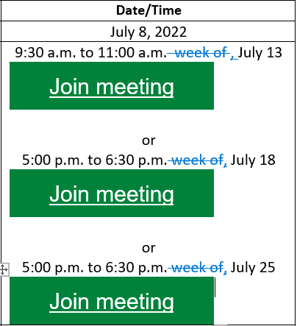
2 |  | 7/13/2022 |  | Section 10.2 evaluation criteria interview language is revised to clarify that interviews will be conducted for the shortlisted firms. Changes shown in track-changes. | Section 10.2 is revised as shown in track changes below:  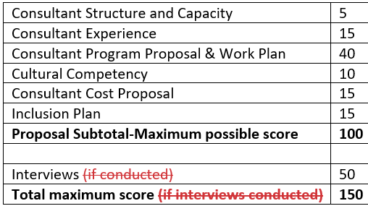
3 |  | 7/13/2022 |  | Sections 8.5 and 10.1 make reference to “RFP Coordinator”. This is changed to “Procurement Contact” for consistency. | Section 8.5 and 10.1 have been updated appropriately with the revisions.
4 |  | 7/13/2022 |  | Attachment H – WMBE Advisory Committee Survey Results is now available in the revised RFP, on page 26. | You may access the Attachment H – WMBE Advisory Committee Survey Results in the revised RFP or via the link here:  https://consultants.seattle.gov/wp-content/uploads/2022/07/City-of-Seattle-WMBE-TA-Survey-Responses.pdf
5 | 7/13/2022 | 7/15/2022 | How will the City assess program effectiveness after 6 months? | Please refer to the Scope of Work under Section 5 of the RFP, specifically the “Metrics and data reporting…” requirements noted under Required Deliverables for both Scope Options 1 and 2.  The City will assess program effectiveness with this reporting and will work with the Consultant to identify areas within the Scope of Work that is working well, what is successful and also identify areas that are lacking and see if any adjustments or changes are needed
6 | 7/13/2022 | 7/15/2022 | What kind of collaboration can we expect with the City staff? It will be difficult to create the onboarding manual and training/advising materials without input from City Staff on common pain points. | The City expects the Consultant to work closely with the Project Manager and department WMBE Interdepartmental Team leads and other City staff to develop these materials.
7 | 7/13/2022 | 7/15/2022 | Do you have an idea of what a cost-per-firm-served amount would be reasonable? | The City has not estimated the costs to provide the services presented in the Scope of Work. The City expects the Proposer(s) to provide a cost proposal as requested under Section 9 of the RFP, Response Material and Submittal, #6. Mandatory – Workplan and Budget.
8 | 7/13/2022 | 7/15/2022 | The two past providers had different approaches in terms of 1:1 advising vs. training. Does the City have a preference for which approach they’d like to see? | The City does not have a preference and expects the Proposer(s) to submit a proposal response that addresses the needs and requirements of the Scope of Work.
9 | 7/13/2022 | 7/15/2022 | Does the City prefer the provider to focus exclusively on City of Seattle based firms? | The City does not have a preference beyond what is described in the RFP.
10 | 7/13/2022 | 7/15/2022 | It would be helpful to track firms’ success in contract and subcontracts with the City. Can the City provide award information on primes and subcontractors so that data and impact can be measured over the course of the two years? | In addition to the answer provided in #5, please refer to Section 10.6 (d) Contract Negotiations in the RFP.  For award information on primes and subcontractors, the City expects the Consultant to track this information through follow up assessments with the clients served, as suggested in 10.6 (b) which will be negotiated with the apparent successful Proposer.
11 |  | 7/15/2022 |  | The attached documents in Sections 9 and 11 of the RFP may not be accessible on all devices. Below, please find the direct links to these documents:  Section 9, 5. Mandatory – Proposal Response:  Scope Option 1:  https://consultants.seattle.gov/wp-content/uploads/2022/07/2.-FAS-2022-002-Proposer-Response-Form-Scope-Option-1_FINAL_CC.docx  Scope Option 2:  https://consultants.seattle.gov/wp-content/uploads/2022/07/3.-FAS-2022-002-Proposer-Response-Form-Scope-Option-2_FINAL_CC.docx  Section 9, 6. Mandatory – Workplan and Budget:  Scope Option 1 Work Plan:  https://consultants.seattle.gov/wp-content/uploads/2022/07/2b.-TAS-Scope-1-WorkPlan_FINAL_CC.docx  Scope Option 1 Cost Proposal Form:  https://consultants.seattle.gov/wp-content/uploads/2022/07/2a.-TAS-Scope-1-Cost_FINAL_CC-1.docx  Scope Option 2 Work Plan:  https://consultants.seattle.gov/wp-content/uploads/2022/07/3b.-TAS-Scope-2-WorkPlan_Final_CC.docx  Scope Option 2 Cost Proposal Form:  https://consultants.seattle.gov/wp-content/uploads/2022/07/3a.-TAS-Scope-2-Cost_FINAL_CC-1.docx  Section 11, 11.7 Insurance Requirements:  https://consultants.seattle.gov/wp-content/uploads/2022/07/InsuranceTransmittalForm_FINAL_CC.docx  Section 11, 11.8 Attachments:  Attachment B: 2017 WMBE Survey:  https://consultants.seattle.gov/wp-content/uploads/2022/07/Attachment-B_2017-WMBE-Survey_CC.pdf  Attachment C: 2018 WMBE Survey:  https://consultants.seattle.gov/wp-content/uploads/2022/07/Attachment-C_2018-WMBE-Survey_CC.pdf  Attachment D: Original Technical Assistance Contract with PTAC:  https://consultants.seattle.gov/wp-content/uploads/2022/07/Attachment-D_Original-TAS-Contract-with-PTAC_CC.pdf  Attachment E: Final Report from first Technical Assistance Services Contract:  https://consultants.seattle.gov/wp-content/uploads/2022/07/Attachment-E_Final-Report-from-first-TAS-Contract_CC.pdf  Attachment F: Annual Report from current NWMMSDC Technical Assistance Services Contract:  https://consultants.seattle.gov/wp-content/uploads/2022/07/Attachment-F_12-Month-report-31122_CC.pdf  Attachment G: 2021 Technical Assistance Services Survey Summary:  https://consultants.seattle.gov/wp-content/uploads/2022/07/Attachment-G_2021-TAS-Survey-Summary_CC.pdf  Attachment H: WMBE Advisory Committee Survey Results  https://consultants.seattle.gov/wp-content/uploads/2022/07/City-of-Seattle-WMBE-TA-Survey-Responses.pdf | Direct links have been added to the embedded documents in Sections 9 and 11.
12 |  | 7/20/2022 | Optional Pre-Submittal Virtual Links for 7/13/2022 and 7/18/2022 | Click on the links below to access the recorded Optional Pre-Submittal Virtual meetings:  7/13/2022:  https://seattle.webex.com/webappng/sites/seattle/recording/home  7/18/2022:  https://seattle.webex.com/seattle/ldr.php?RCID=9343e5eb7be2dc352fc0d848aa4af845
13 |  | 08/02/2022 |  | New Optional Pre-Submittal Virtual Meeting is added, scheduled for 08/09/2022, from 10:00 am – 11:30 am  Join meeting  If you are not able to join, please be sure to view the posted recording when it becomes available. | Updates have been made to the RFP Procurement Schedule
14 |  | 08/02/2022 |  | Deadline for Questions is extended to 08/16/2022 | Updates have been made to the RFP Procurement Schedule
15 |  | 08/02/2022 |  | RFP Response Deadline is extended to 08/23/2022 | Updates have been made to the RFP Procurement Schedule
16 | 08/01/2022 | 08/19/2022 | May we get a copy of the City of Seattle procurement or purchasing manual? | The City may provide copies of relevant procurement guidelines or manuals to the successful proposer(s) after award. | No Changes
17 | 08/01/2022 | 08/19/2022 | Are you open to Automation and technological improvement suggestions in the response? | The City is open to automation and technological improvement suggestions as long as it meets the Scope of Work criteria and deliverable requirements for the RFP. | No Changes
18 | 08/01/2022 | 08/19/2022 | Choice of Scope (Option 2):  What is considered a subconsultant? What does it pertain to? Paid or non-paid contractor? Can they be within the organization just in a different department (we provide in house services to business owners). | Subconsultants are considered those firms the prime contracts with to perform work as a Tier 2 contractor to assist and perform the work in the Scope of Work. Internal employees of the prime consultant are not considered and will not be recognized as subconsultants. | No Changes

